INSPECTION & SPECIFICATION SERVICES CC.
ISS
CONTROLLED ENGINEERING INSPECTION REPORT
Combined-Product Spillage
Inspection and Engineering Assessment Report
South32 Wessels Mine · Surface and Underground Conveyor / Process Areas
ASSEMBLY DRAFT · REVISION 0.2 · NOT FOR ISSUE

Client | South32
Mine / site | Wessels Mine
Area / system | Combined-product handling and processing systems - selected surface and underground sections
Report number | S32WPPSR-01
Revision | 0.2 - Assembly Draft
Issue date | 25 August 2026
Inspection date / range | [INSPECTION DATE / DATE RANGE]
Prepared by | Inspection & Specification Services cc.
Inspection & Specification Services cc.
Reg. No. 1990/020258/23
24 Jonkershoek Street, Vaalpark, 1947
iss@inspecserv.co.za

Document Control and Metadata
Table 1 - Document control and report metadata
Field | Value
Report title | Combined-Product Spillage Inspection and Engineering Assessment Report
Report number | S32WPPSR-01
Revision | 0.2
Issue status | Assembly Draft / Not for Issue
Issue date | 25 August 2026
Client | South32
Mine / site | Wessels Mine
System | Combined-product handling and processing systems
Primary drafting source | Running_Report_Contextual_Spillage_NotesV3.9.docx + Phase 6 Addendum
Evidence register | EVIDENCE_STORY_MATRIX_V0.1.csv — 197 controlled media / 75 E / 44 S / 78 A / 0 X
Template lineage | Adapted from ISS Sheave Inspection Report Master Template v2.1 structure

Prepared, Reviewed and Approved
Table 2 - Document authorization record
Role | Name | Title / Discipline | Date | Signature
Prepared by | [PREPARED BY] | [TITLE] | [DATE]
Reviewed by | [REVIEWED BY] | [TITLE] | [DATE]
Approved by | [APPROVED BY] | [TITLE] | [DATE]

Revision History
Table 3 - Revision history
Revision | Date | Change description | Prepared by | Approved by
0.1 | [DATE] | Initial spillage-report working base adapted from ISS sheave-report structure using consolidated Contextual Notes V3.7 and completed evidence review. | [NAME] | [NAME]
0.2 | 25 Aug 2026 | Phase 6 assembly draft: accepted narrative architecture + evidence hierarchy + CV09 holistic evidence grammar integrated into one full report structure. | ISS | Draft review

Controlled Distribution
Table 4 - Controlled distribution list
Recipient / role | Organisation | Purpose | Controlled copy
[CLIENT CONTACT] | South32 | Review / action tracking | [YES / NO]
[ISS FILE] | ISS | Controlled project record | Yes
ASSEMBLY-DRAFT CONTROL NOTE
This revision is the first full narrative/evidence assembly after Phase 5 prototype acceptance. Content architecture and engineering coherence are under review. Final typography, colour, figure numbering, automatic registers and issue formatting are deliberately deferred.
This file is the adapted report base. It intentionally contains a mixture of populated context, evidence references and controlled placeholders. Values such as report number, issue date, authorisation, formal severity/priority and any client-specific acceptance criteria must be confirmed before issue.

Table of Contents
1 Executive Summary
2 Purpose and Objectives
3 Scope of the Audit
4 Methodology, Evidence Basis and Limitations
5 The Material Journey
6 Central Audit Principle — Spillage Location Is Not Always Cause Location
7 The Overall Spillage Picture
8 Fines Are Being Lost Progressively Through the Conveyor Ecosystem
9 Why Belt Cleaning Alone Is Not the Full Control Function
10 Proposed Cleaner / Fines-Control Philosophy
11 The Containment Problem Is Not Limited to Fines
12 W10 — Coarse Product Loss in a Confined Tunnel
13 Sample Conveyors — Product Size, Feed and Limited Carrying Width
14 Belt Tracking as a Material-Containment Requirement
15 U4 Tripper Car — Strong Local Cause-and-Effect Example
16 L3 — Alignment Concern Without Proven Solid-Product Causal Chain
17 Water as a Material-Transport and Deterioration Mechanism
18 Screens — Confirmed Water Escape / Separate Structural Story
19 L1 — Spillage, Historical Belt Contact and Structural Deterioration
20 Trips, Restart and Manual Product Removal
21 Housekeeping — Necessary but Not the Primary Solution
22 Consolidated Engineering Interpretation
23 Keep the Combined Product Inside the Process
24 Priority 1 — Prove System-Level Source-Control Concepts
25 Priority 2 — Correct Confirmed Local Material-Loss Mechanisms
26 Priority 3 — Water and Structural Actions
27 Priority 4 — Extend Proven Controls Where Applicable
28 Priority 5 — Operational and Housekeeping Controls
29 Conclusion
Page numbers are intentionally not frozen in this Phase 6 assembly draft. Refresh the automatic Table of Contents, List of Figures and List of Tables during the document-wide formatting phase.

List of Figures
Figure numbering and final captions remain provisional during assembly. Canonical evidence IDs are retained under every embedded evidence image.

List of Tables
Table numbering and final cross-references will be refreshed after content architecture stabilises.

PART I — WHY THE AUDIT WAS UNDERTAKEN

1 Executive Summary
Spillage was observed at multiple locations across the Wessels material-handling system, from the underground crusher and conveyor route through the surface screening and loading-station areas. The audit was undertaken to determine whether these deposits were isolated housekeeping problems or evidence of broader failures to retain product and process water within their intended handling envelopes.
The audit found that there is no single universal spillage mechanism. The strongest recurring system pattern is fines/carryback, supported by repeated fines accumulation along return-side and downstream conveyor areas. Additional local mechanisms include coarse or mixed product leaving the carrying envelope during transit, belt mistracking/alignment, limited loading or side-containment margin, process-water escape, and event-driven material removal following trips or blockages.
A central finding is that the location where spilled material accumulates is not necessarily the location where the initiating failure occurs. Fines may remain on a return belt after discharge and detach progressively downstream; water may mobilise fines away from an original escape point; mistracking may develop before product is lost; and trip/restart clearing can create a secondary deposit away from the initiating event.
Taken together, the evidence indicates that increased housekeeping alone will not provide a sustainable long-term solution. The higher-order engineering objective is to keep the combined product — fines and coarse/lump ore — inside the intended process/material-handling envelope throughout transit and to manage process water within its designed envelope.
AUDIT TAKEAWAY | The mine has a material-containment problem with several mechanisms, not simply a housekeeping problem or a collection of unrelated scraper defects.
The recommended programme therefore combines a system-level source-control philosophy with targeted local actions. CV09 is the preferred pilot for development of an integrated cleaner-and-containment function. W10, Sample Conveyors 2 and 3, U4, the Screens and L1 require location-specific engineering because their mechanisms and geometry differ.

2 Purpose and Objectives
The purpose of the audit is to identify where combined product or process water is escaping its intended handling path, determine the mechanisms and contributing conditions associated with those losses, distinguish recurring system mechanisms from local asset-specific conditions, and define practical engineering, maintenance and operational actions that can reduce recurrence.
- Identify the material types and locations at which visible losses occur.
- Determine the immediate mechanism and contributing condition where the available evidence supports that conclusion.
- Distinguish visually proven conditions from inspector-recorded observations, engineering interpretation and unresolved verification items.
- Develop practical source-control, containment, maintenance, alignment, structural and operational actions.
- Provide a controlled evidence record that allows engineering and maintenance personnel to trace each major conclusion back to the inspection evidence.
The audit is qualitative and mechanism-focused. It does not attempt to infer total lost tonnage or volume from photographs. Visible extent is used as an indicator of severity or persistence, not as a substitute for measurement.

3 Scope of the Audit
The inspected locations form one connected material-handling route and are treated as an ecosystem rather than as an unrelated list of assets.
Process area | Included assets / groups
Underground — Central Block | Underground Crusher; UC05 / UC04 / UC03 / UC02 / UC01 continuous conveyor system
Underground — Secondary Plant | U3 Conveyor; U4 Tripper Car
Underground — Silos / Feeders | U5A Conveyor; U5B Conveyor
Surface — Screening / Transfer | W10; CV01; CV02; CV03; CV04; CV06; CV09; CV14; CV15; Screens / screen chutes
Surface — Loading Station | L1; L2; L3; L4; Sample Conveyors 1, 2 and 3
CV05, CV07, CV08, CV10, CV11, CV12 and CV13 are outside the integrated scope of this report. The evidence record remains limited to the 23 controlled inspection groups represented in the final evidence matrix.

4 Methodology, Evidence Basis and Limitations
The assessment combines site inspection observations, still photographs, inspection videos, the completed questionnaires, the running contextual engineering notes and the final 197-item evidence/story matrix. Each evidence item retains its canonical evidence ID so that the report body can remain readable without losing technical traceability.
Evidence / statement type | Meaning in this report
Direct observation | Condition recorded directly during the inspection by the inspector.
Visual evidence-supported | Condition materially demonstrated by supplied photographs or video.
Source-recorded information | Operating, maintenance or historical information retained from inspection records/questionnaires.
Engineering interpretation / hypothesis | Reasoned explanation consistent with the observed condition but not fully proven by the available evidence.
Working remedial concept | Engineering direction requiring measurement, feasibility and design verification before implementation.
Unresolved / requires verification | Condition or magnitude that cannot be responsibly closed from the present evidence.
The inspection was performed around operating industrial equipment and access was therefore limited at some points. Where belt offsets, pulley alignment, scraper contact pressure, remaining structural capacity, chute dimensions or design capacities were not measured, the report deliberately carries those items forward as verification or design-development requirements.
PART II — UNDERSTANDING THE MATERIAL-HANDLING SYSTEM

5 The Material Journey
The material handled by the inspected system is combined product comprising lump/coarse ore together with fines. Fines are already present after blasting and additional fines are generated during crushing and subsequent handling. The fine fraction is therefore part of the product stream rather than an inherent defect.
From the underground crusher onward, the conveyor system is intended to transport this combined material through successive transfer and processing stages while retaining it inside the designed material path. The audit problem is not that fines or lump ore exist; it is that portions of the product stream are escaping the intended process envelope before they reach the stage designed to handle or separate them.
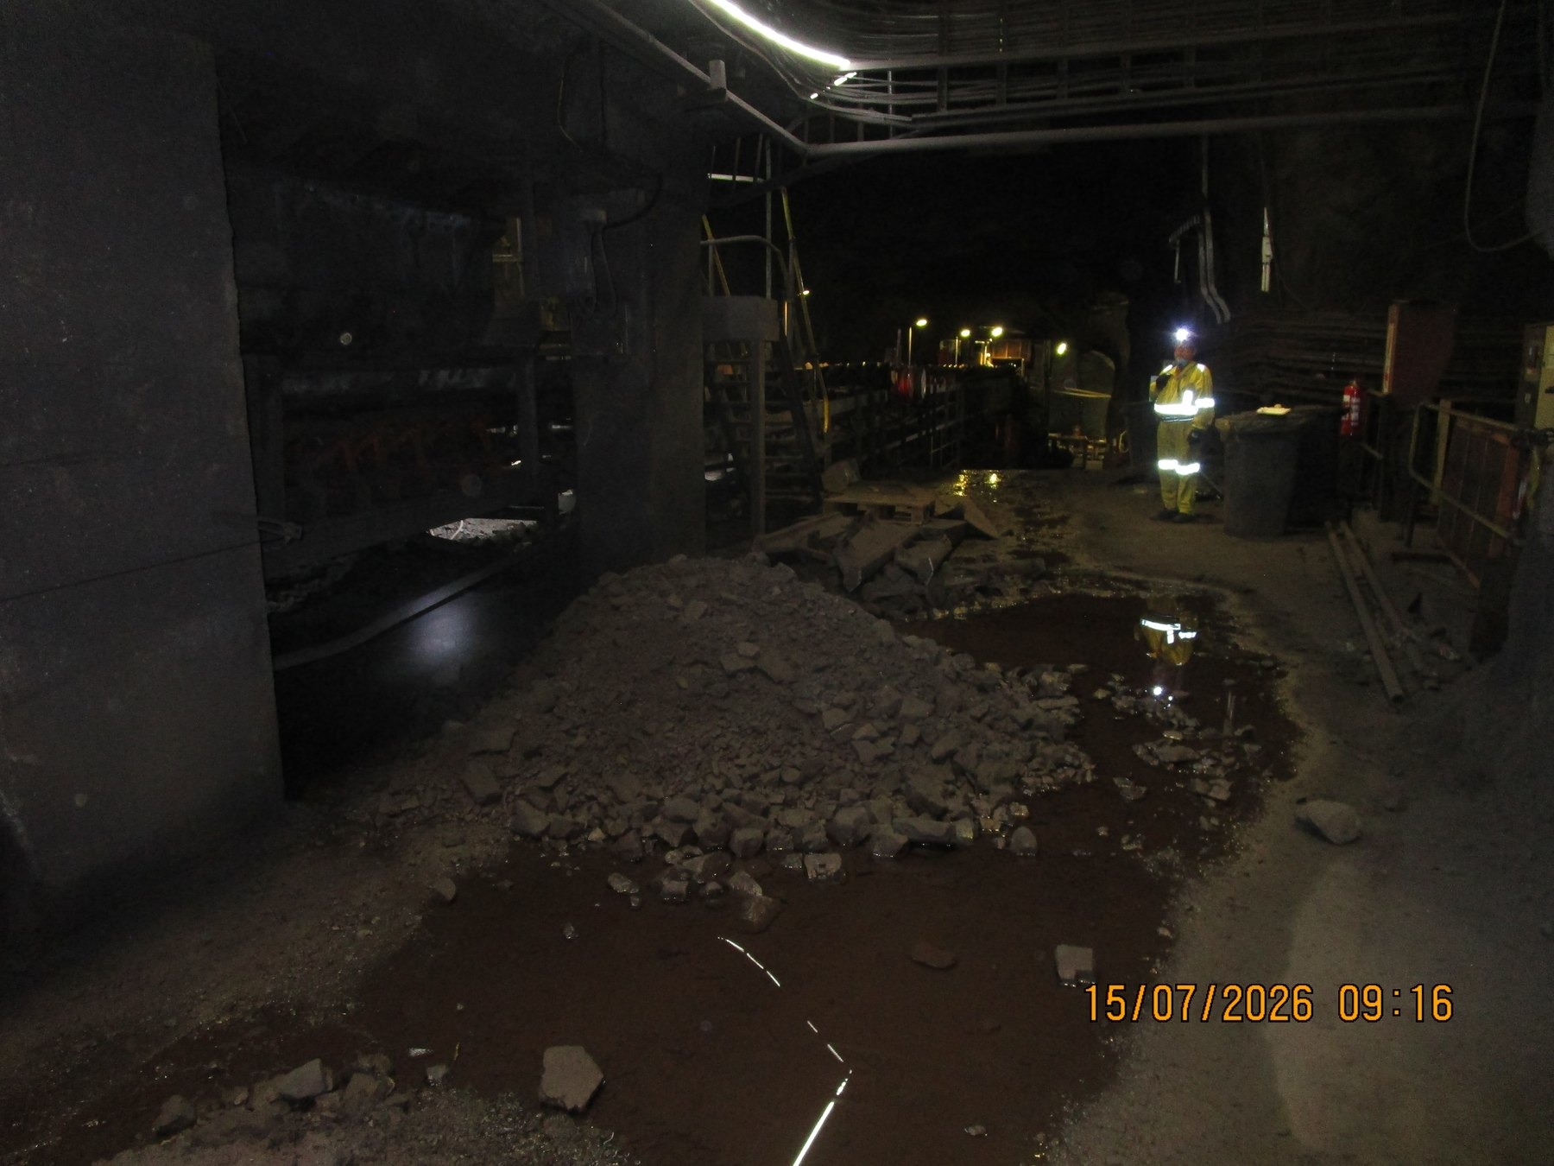  UGCrusher-REF-001 — mixed lump/fines accumulation at the underground start of the inspected conveyor ecosystem. | 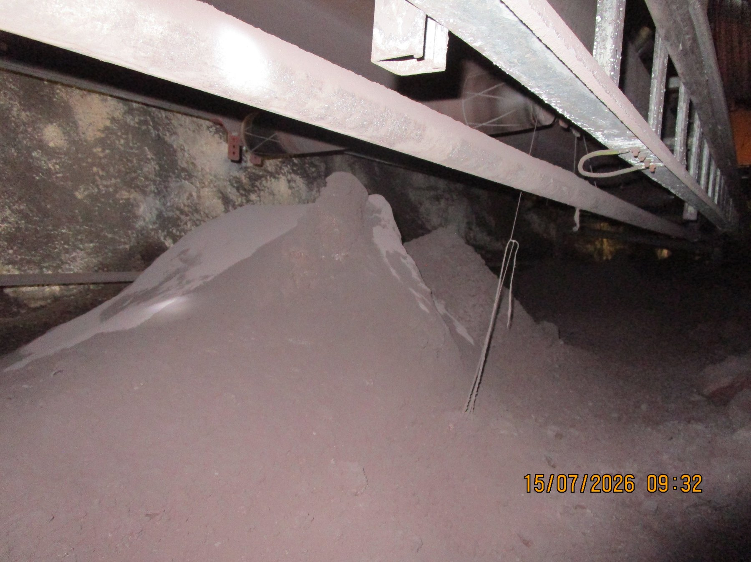  UGUC05_04_03_02_01-REF-006 — severe local accumulation along the continuous underground conveyor route.
READER TAKEAWAY | The report concerns loss of process containment during transport — not the mere presence of fines or lump ore.

6 Central Audit Principle — Spillage Location Is Not Always Cause Location
Visible spillage should not automatically be interpreted as a local failure at the point where the material is found. A deposit may be the final consequence of an initiating condition that is upstream or functionally separate from the deposit location.
1. Fines can remain adhered to the return belt after discharge and be detached progressively by downstream rollers.
2. Water can mobilise fines and transport contamination away from the original escape point.
3. Belt mistracking can reduce the usable carrying margin before product is lost at a later position.
4. Trip/restart clearing can place material beside a conveyor even though the initiating event occurred elsewhere.
CAUSE / EFFECT SEQUENCE | Observed deposit → material type → immediate mechanism → contributing condition → initiating cause → consequence → control
PART III — WHAT THE AUDIT FOUND

7 The Overall Spillage Picture
The evidence resolves into three recurring material-loss families and one event-driven operating mechanism. These mechanisms can overlap at individual assets, but they do not all require the same control.
Mechanism family | Typical evidence / significance | Control direction
Fines / carryback | Recurring deposits along return-side and downstream conveyor areas; cleaner condition and containment are recurring themes. | Improve cleaning function and retain removed fines inside the process.
Coarse / mixed product transit loss | Product outside the carrying envelope at W10, Sample Conveyors and other local positions. | Feed/trajectory, tracking and location-specific containment.
Water / wet fines / slurry | Wet deposits and confirmed active screen water escape. | Retain process water; identify local escape mechanism; manage secondary structural consequences.
Trip / restart unloading | Source-recorded manual clearing after trips/blockages. | Defined temporary laydown, recovery and restart procedure.
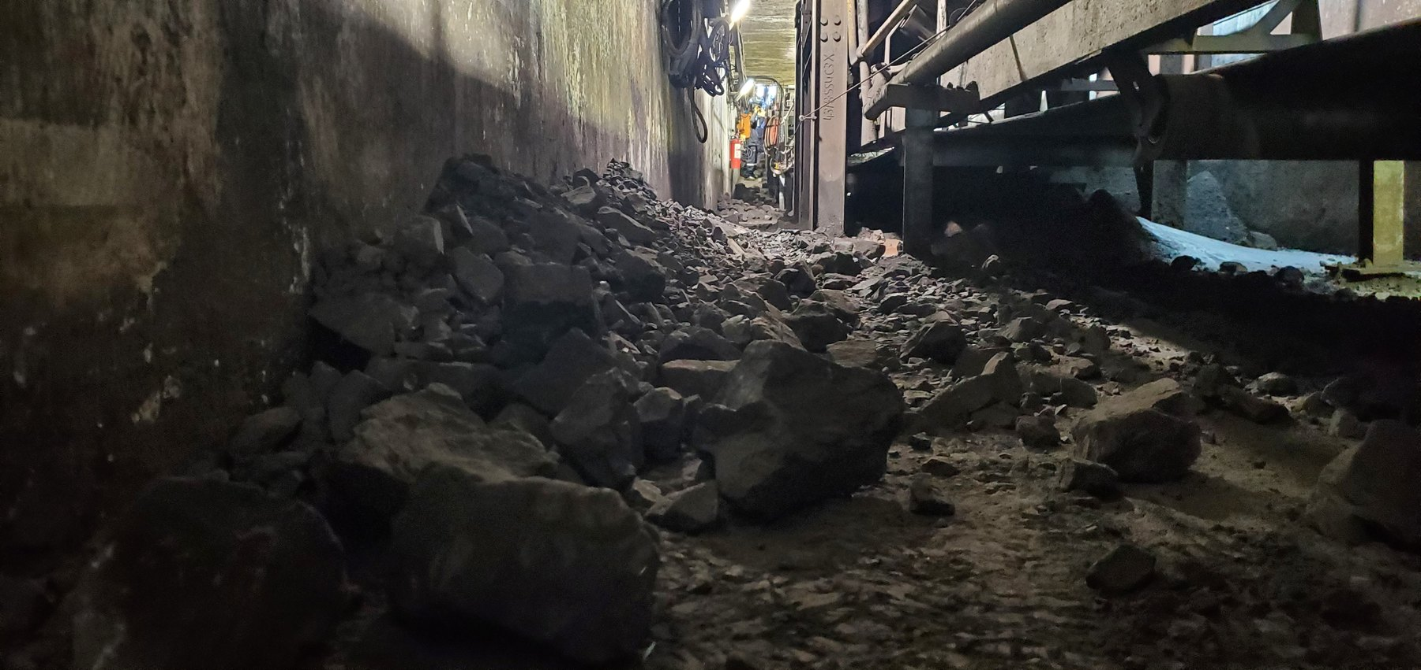  W10-REF-002 — coarse/mixed product occupying restricted tunnel access. | 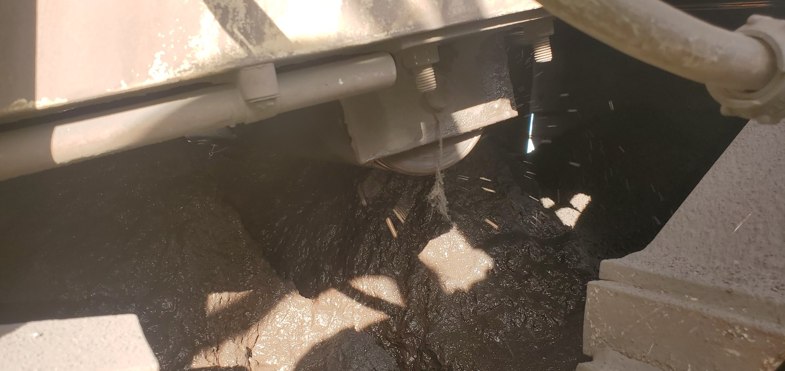  CV04-REF-002 — saturated wet-fines/slurry condition.
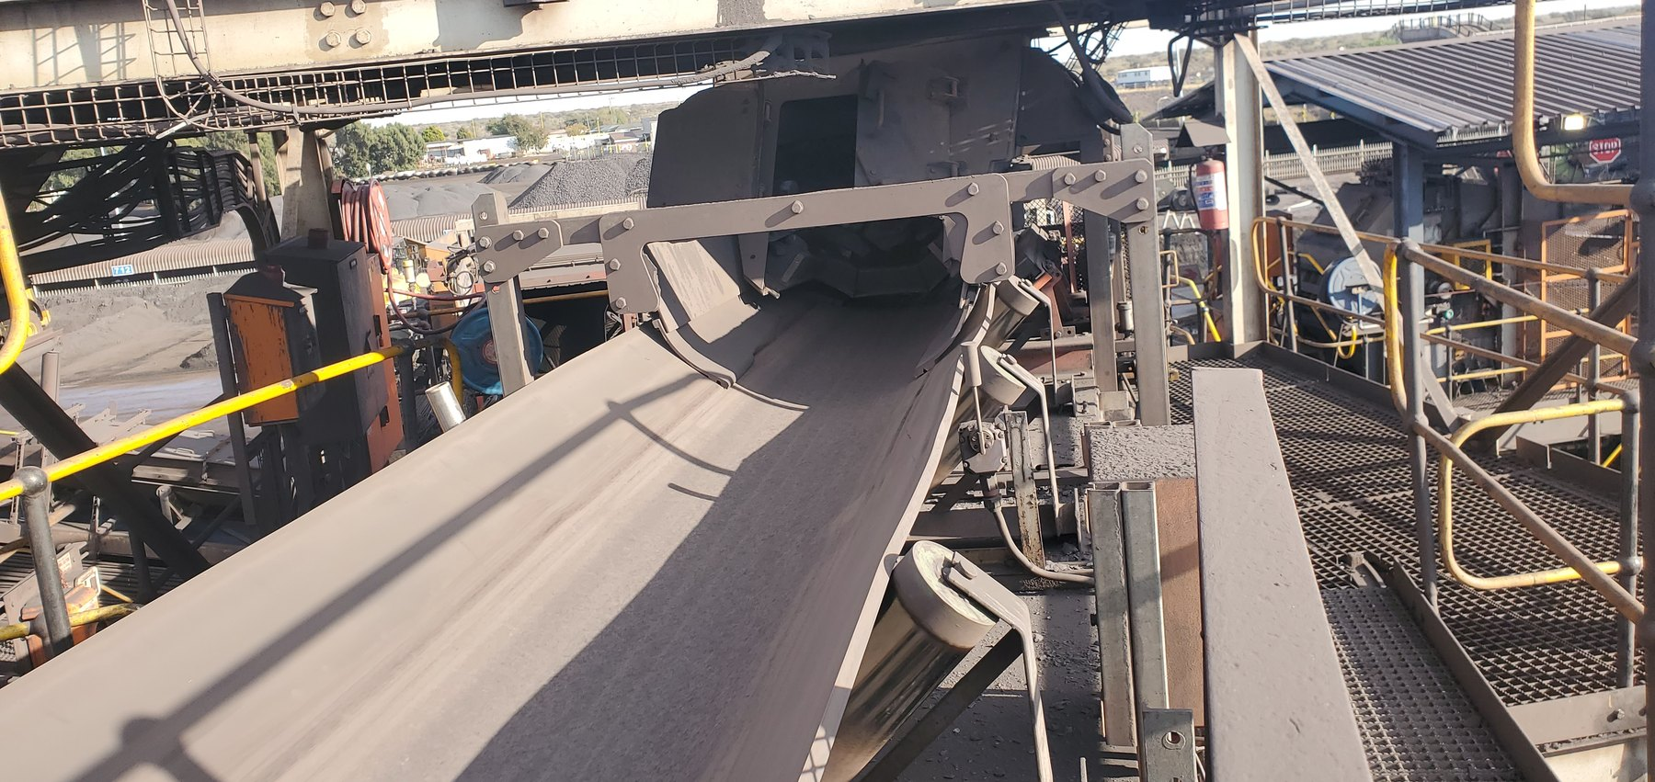  CV03-REF-002 — clean-condition comparator demonstrating that not every inspected conveyor was a significant spillage location. | 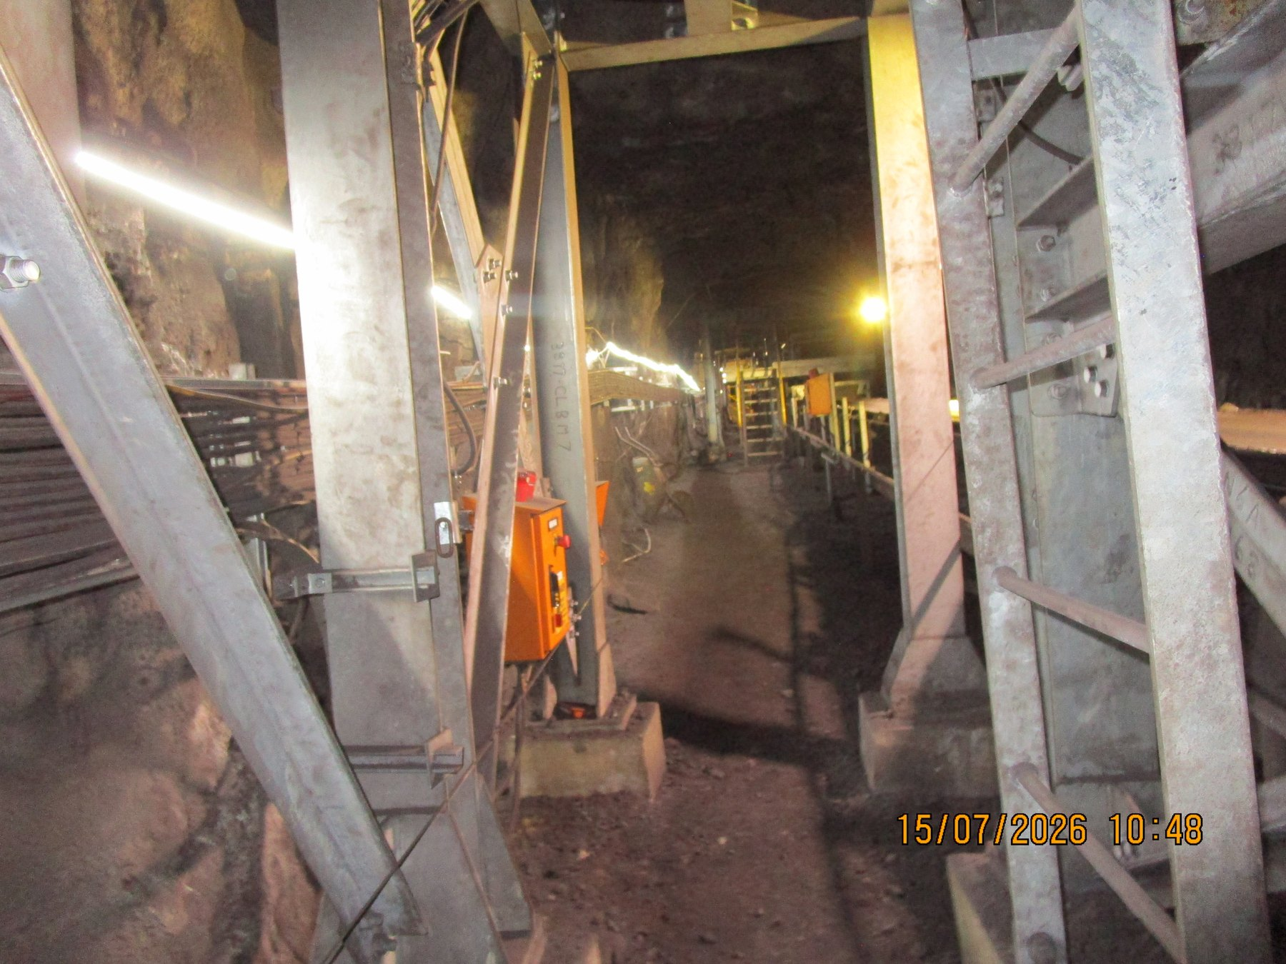  UG5B-REF-006 — wider comparator supporting a localised rather than uniformly widespread U5B condition.
PART IV — FINES, CARRYBACK AND CLEANER CONTAINMENT

8 Fines Are Being Lost Progressively Through the Conveyor Ecosystem
Recurring fines accumulation was observed across multiple underground and surface conveyors. The repeated relationship between deposits and return-side/support-roller areas is consistent with fines remaining on the belt after the head discharge and being released progressively downstream.
The exact origin of every individual deposit cannot be assigned from a still photograph, but the cross-system recurrence is important. It means a large deposit below a downstream return route may be the consequence of ineffective fines control at the preceding discharge rather than a defect at the exact point where the deposit is found.
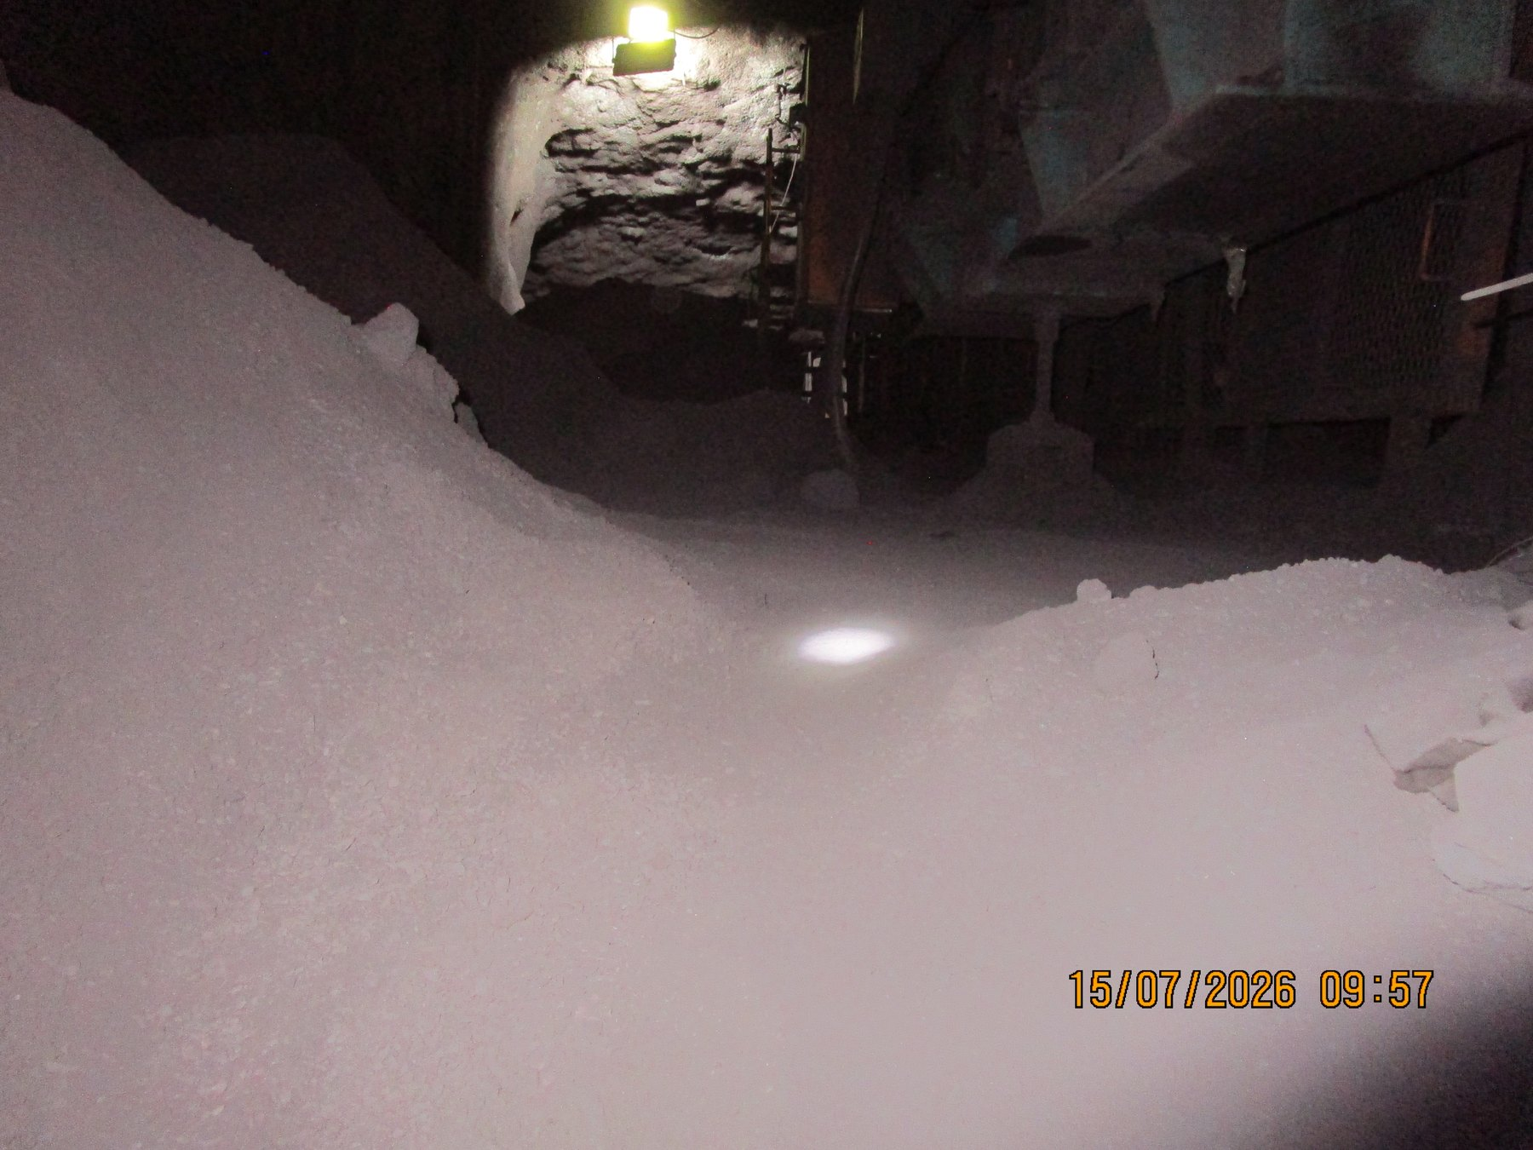  UGUC05_04_03_02_01-REF-015 — wider longitudinal accumulation supporting recurrence along the underground route. | 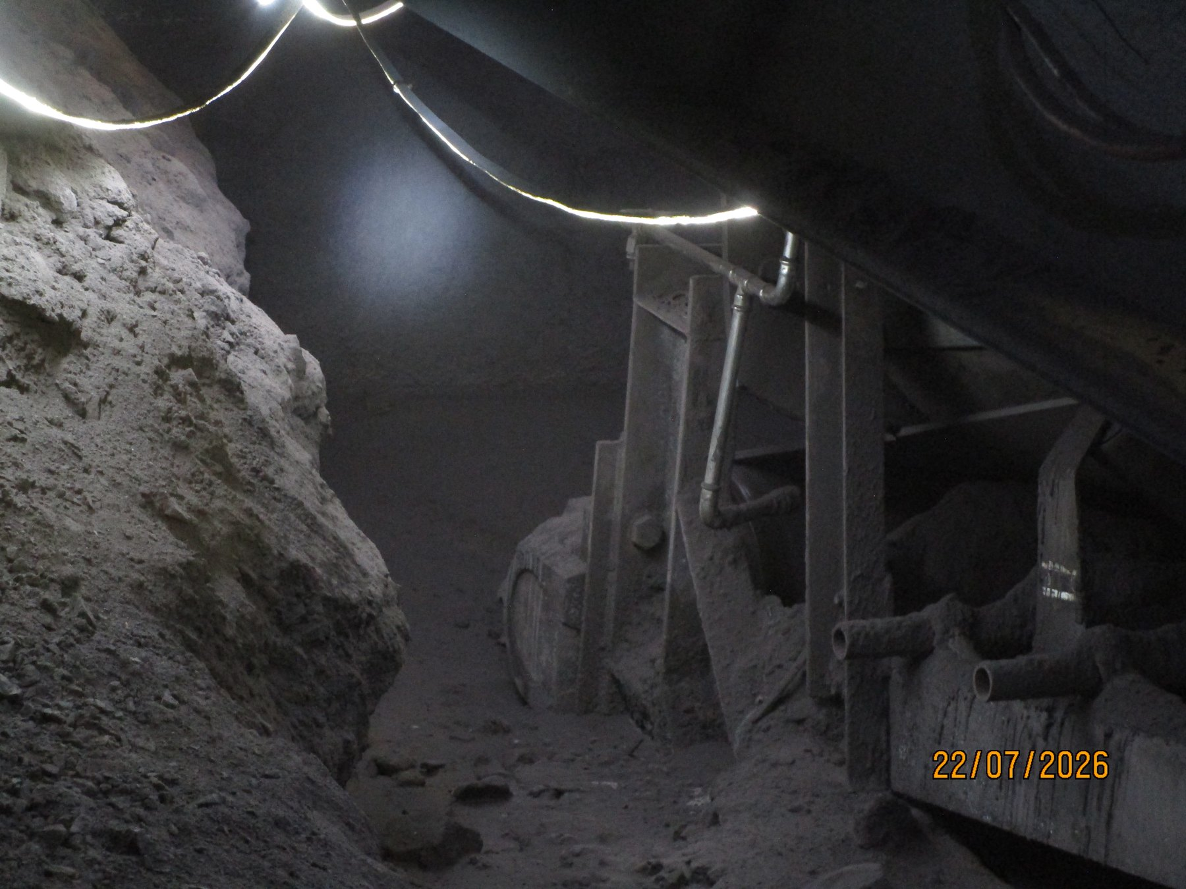  UG5A-REF-006 — widespread return-side accumulation at U5A.
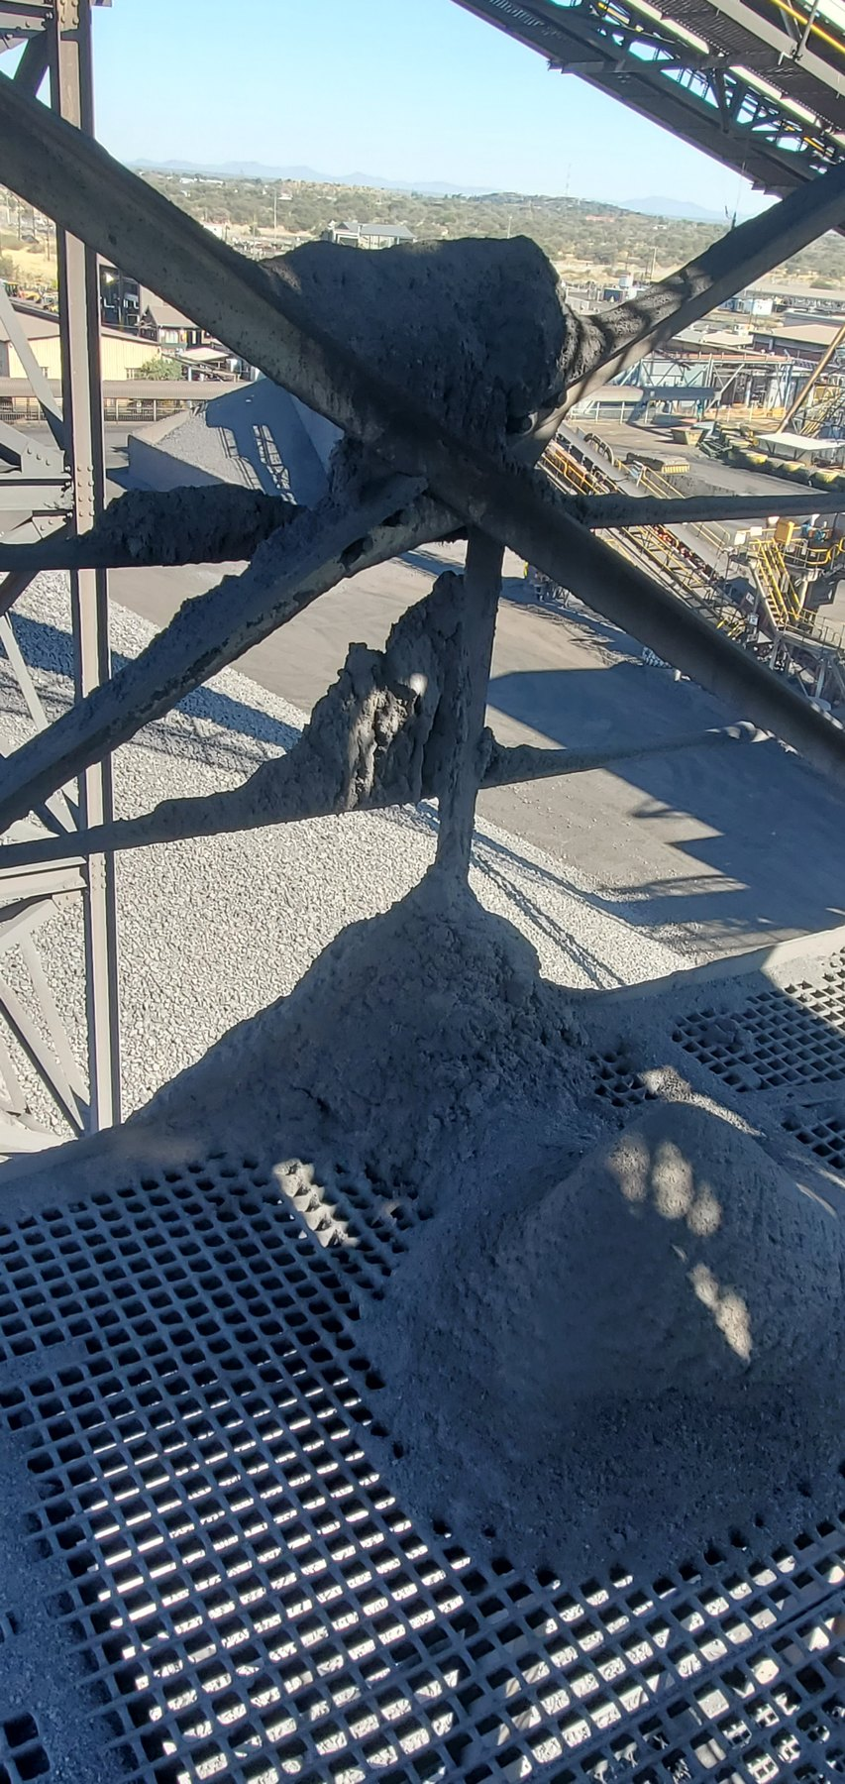  CV15-REF-004 — large fines deposits on grating/cross-bracing around the CV15 discharge region. | 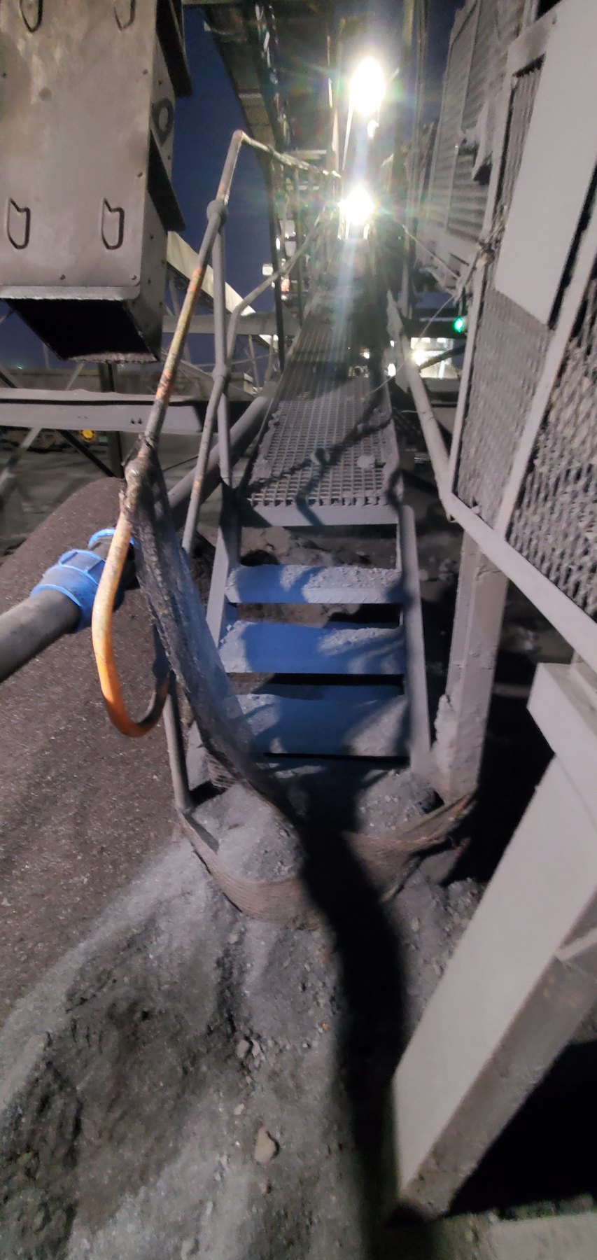  LoadoutStationSample1-REF-002 — substantial fines accumulation around the Sample Conveyor 1 tail/access area.
SYSTEM PATTERN | Carryback is a recurring system mechanism, not an isolated conveyor event. The report therefore focuses on cleaner function and containment at relevant discharges rather than treating each downstream fines pile as an unrelated defect.

9 Why Belt Cleaning Alone Is Not the Full Control Function
A belt cleaner succeeds only when two linked functions are achieved: residual material is removed from the return belt, and the removed material remains inside the intended process/material path. CV06 and CV09 demonstrate different ways in which that overall control function can fail.

9.1 CV06 — Mechanical / Maintenance Failure Example
At CV06 the cleaner cannot perform its intended function because the physical cleaner condition is compromised. The support structure remains installed, but the scraper blade elements are absent across the working belt width and a support bush/insert is displaced.
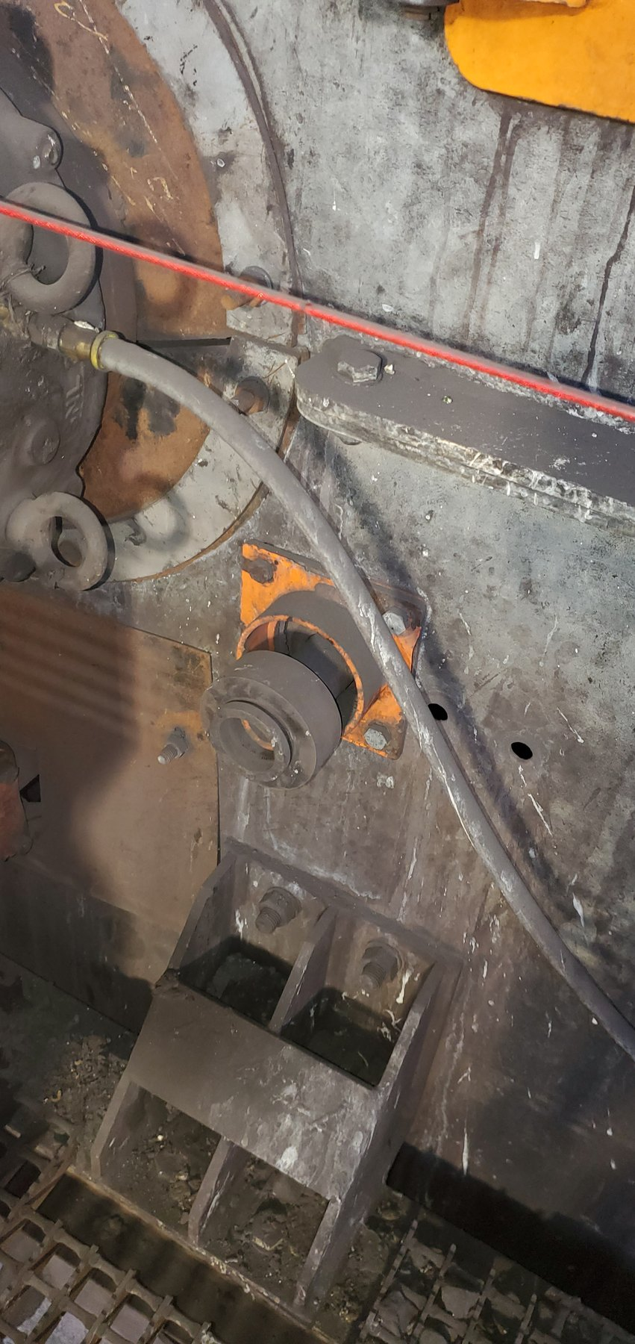  CV06-REF-004 — displaced cleaner support bush/insert. | 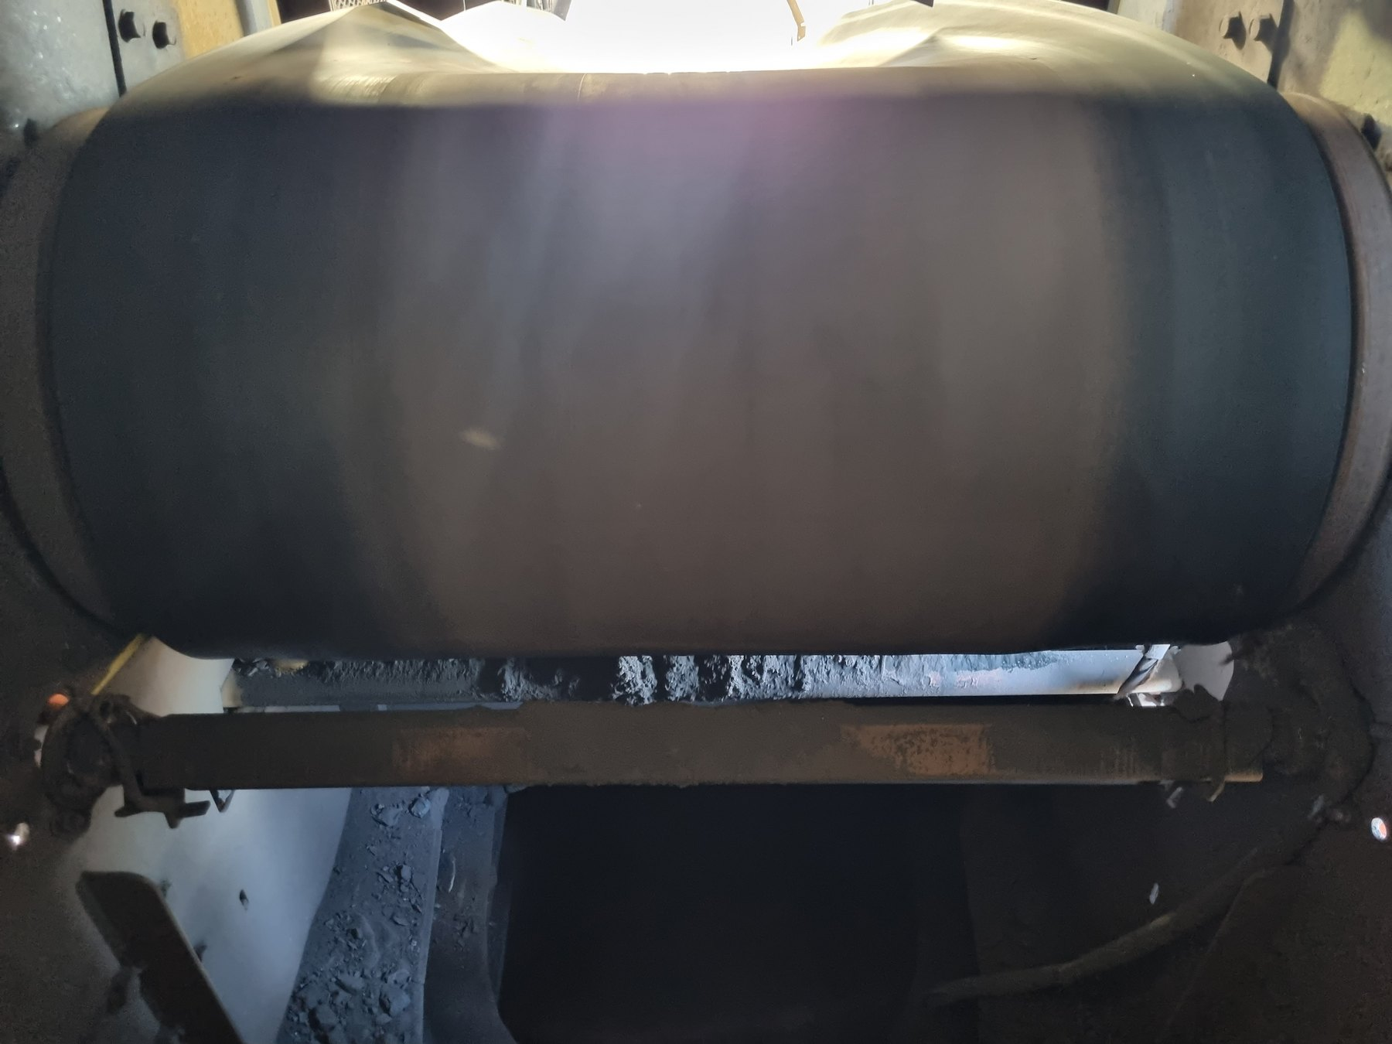  CV06-REF-005 — cleaner support structure present with scraper blades absent from the working belt width.
OBSERVATION | Physical cleaner defects are directly visible at CV06.
ENGINEERING ASSESSMENT | The cleaner is non-functional as intended. The photographs do not establish why the bush displaced or why/when the blades were lost; those remain maintenance/design-history questions.
RECOMMENDED NEXT ACTION | Restore a functional cleaner arrangement and verify the support/housing condition, blade installation, belt contact and maintainability before returning the cleaner to service.

9.2 CV09 — Cleaner Removes Material, But Containment Still Fails
CV09 demonstrates a different failure. Wet residual material is removed from the return belt, but the local cleaner/discharge arrangement is positioned such that removed material is not inherently retained within the effective discharge/process containment envelope. The belt may therefore become cleaner while the plant area below becomes contaminated.
This matters because belt cleaning and containment of the removed material are one engineering function. The evidence sequence below demonstrates the cleaner arrangement, the wet-fines consequence, active fallout during operation and the geometry that makes CV09 a suitable pilot location.
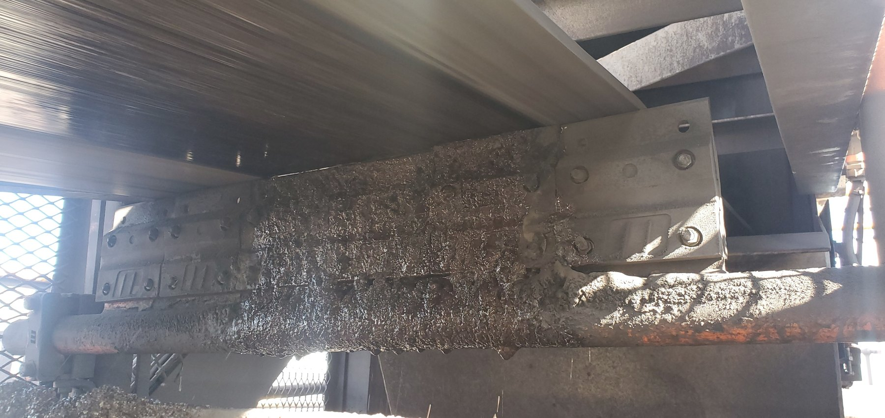  CV09-REF-003 — principal still showing the cleaner/open local arrangement. | 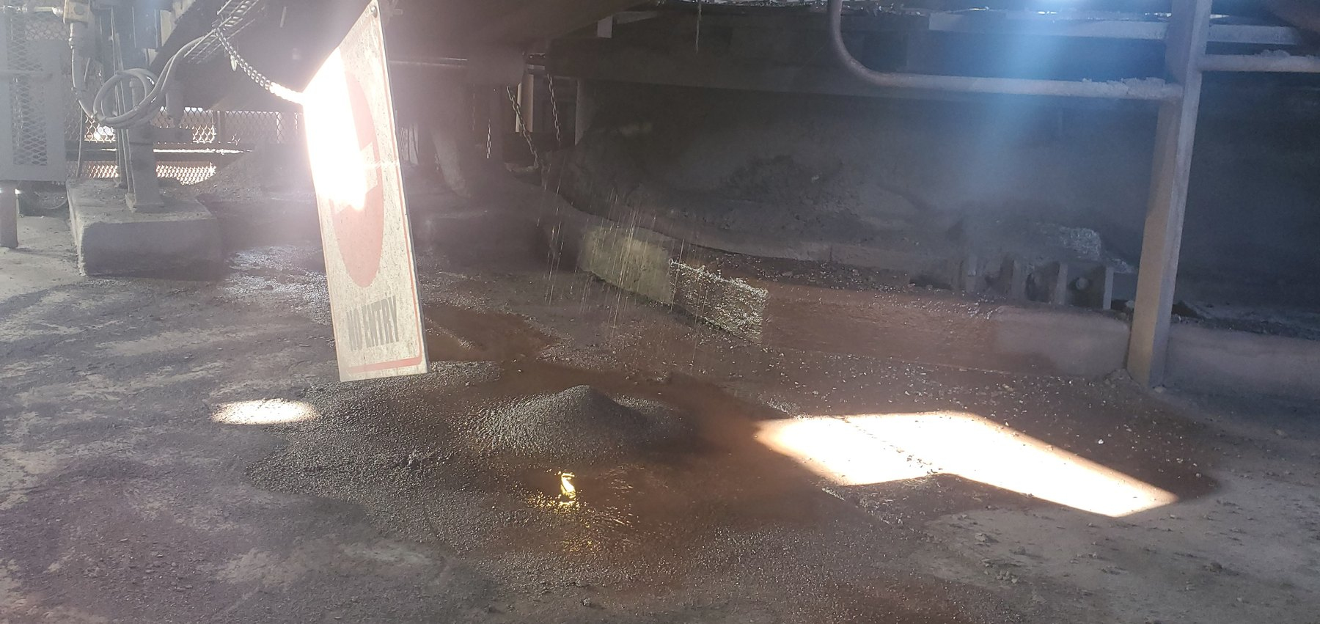  CV09-REF-002 — wet-fines/slurry consequence below the discharge/cleaner region.
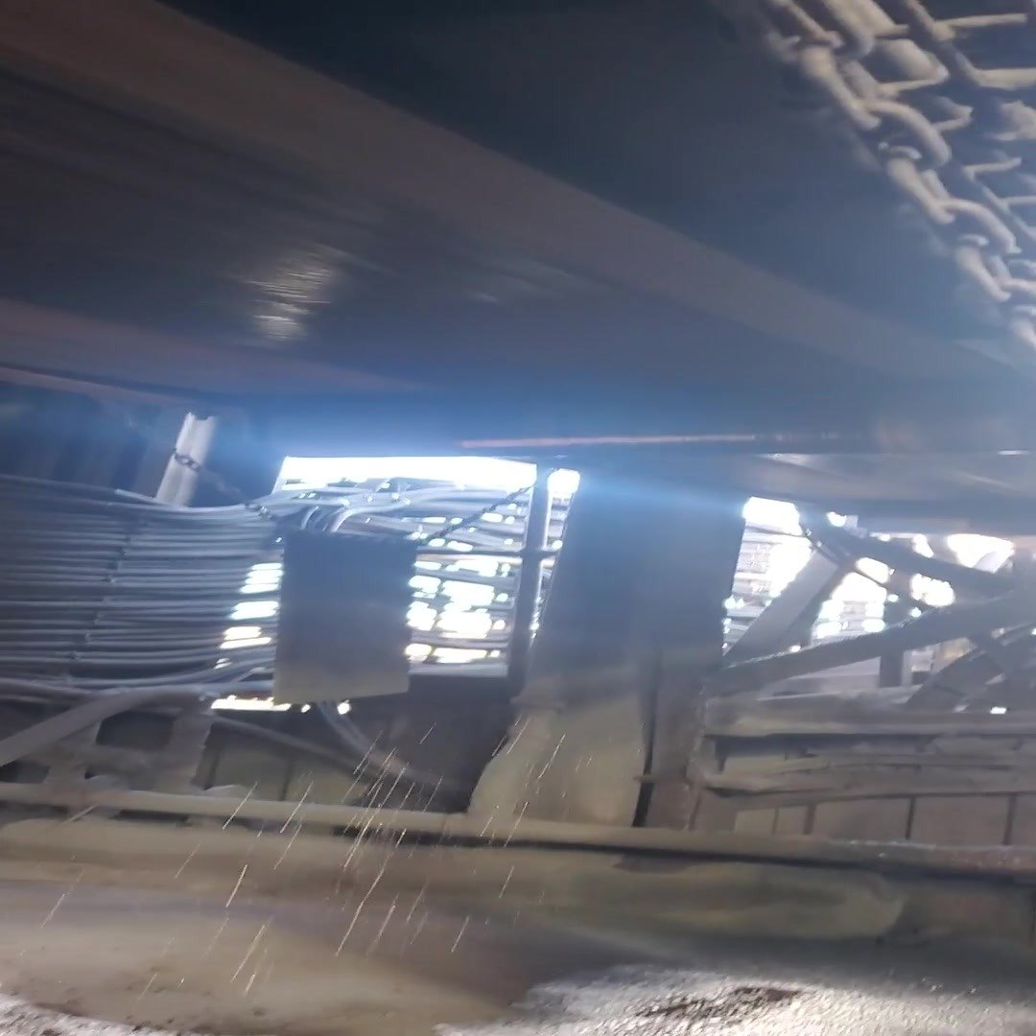  CV09-REF-006 — representative frame from inspection video showing active wet-material fallout during operation. | 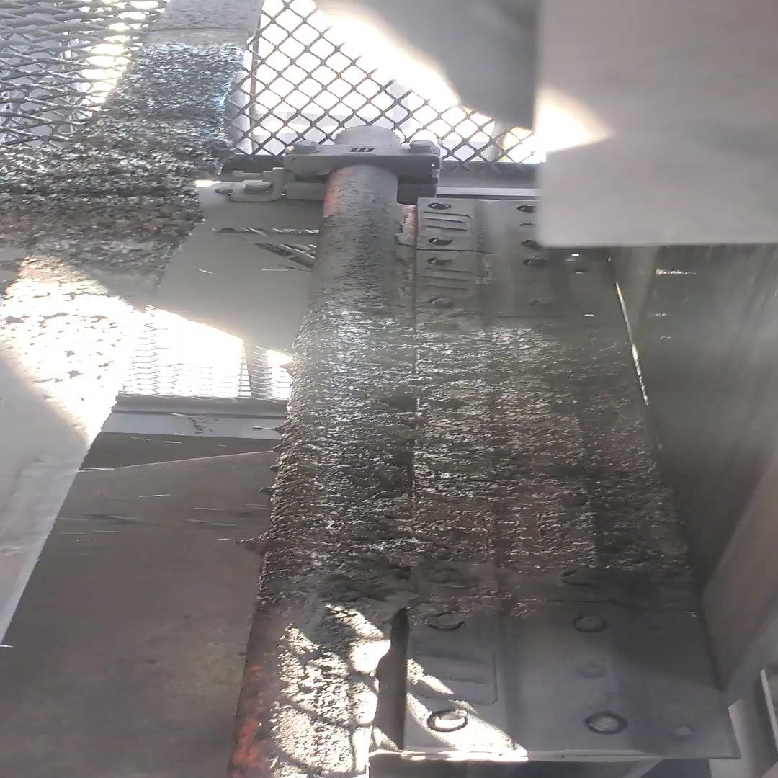  CV09-REF-008 — representative frame from inspection video showing contaminated cleaner/chute geometry relevant to the containment-boundary issue and pilot concept.
OBSERVATION | Wet fines/slurry are present below CV09 and active wet-material fallout was recorded during operation.
ENGINEERING ASSESSMENT | The cleaner removes material from the belt, but the local arrangement does not adequately retain that removed material within the intended downstream process/fines-handling route. Final cleaner type, contact pressure, chute dimensions, supports and access geometry are not defined by the present evidence.
CONTROL PHILOSOPHY | Do not merely clean the belt. Keep the fines inside the process.
RECOMMENDED NEXT ACTION | Develop and trial a CV09 cleaner/containment arrangement after verifying belt/discharge geometry, containment envelope, mounting, wear compensation, access, maintainability, safety and the downstream fines route.

9.3 What CV09 Means Beyond CV09
Taken together, CV06, CV09 and the inspector-recorded CV15 cleaner condition show why the mine should standardise the required material-control function rather than one identical scraper design. A successful arrangement must maintain effective belt contact as wear develops, remove residual material and direct that material into the intended process stream.

10 Proposed Cleaner / Fines-Control Philosophy
CV09 is the preferred pilot because its failure mechanism is directly demonstrated and the intended destination for removed fines is identifiable. The pilot should prove a functional arrangement rather than prematurely prescribe one final hardware detail.
- Maintain effective cleaner-to-belt contact as the blade wears.
- Provide appropriate wear compensation / travel limitation and stable support.
- Direct removed wet fines into the intended chute/process stream.
- Keep the cleaner inside an effective containment envelope.
- Retain safe inspection and maintenance access.
- Consider primary/secondary cleaning where justified by local belt and material conditions.
STANDARDISE THE FUNCTION | This is not a recommendation to install one identical scraper at every conveyor. Prove the required cleaner/containment function at CV09, then assess location-specific applicability elsewhere. U4 remains an explicit geometry-specific exception.
PART V — COARSE / COMBINED-PRODUCT LOSS DURING TRANSIT

11 The Containment Problem Is Not Limited to Fines
The inspection also identified locations where coarse/lump or mixed product had left the carrying belt during transit. These conditions cannot be explained by return-side carryback and require a separate control philosophy focused on keeping product within the usable carrying envelope until the intended transfer or discharge point.
Potential contributors include feed quantity and product size, loading trajectory, limited usable belt width, mistracking, transfer geometry and insufficient local lateral containment. The correct control depends on which mechanism is supported at each location.

12 W10 — Coarse Product Loss in a Confined Tunnel
W10 is significant because substantial coarse/mixed-product accumulation is present outside the intended belt path in a confined tunnel. The evidence does not isolate one definitive initiating cause for every deposit, so the report does not assign one unsupported root cause.
What is established is that product has left the carrying envelope and entered a restricted access zone. In this geometry, material loss has a disproportionate operational consequence because escaped product occupies limited access space and creates repeated recovery/housekeeping demand.
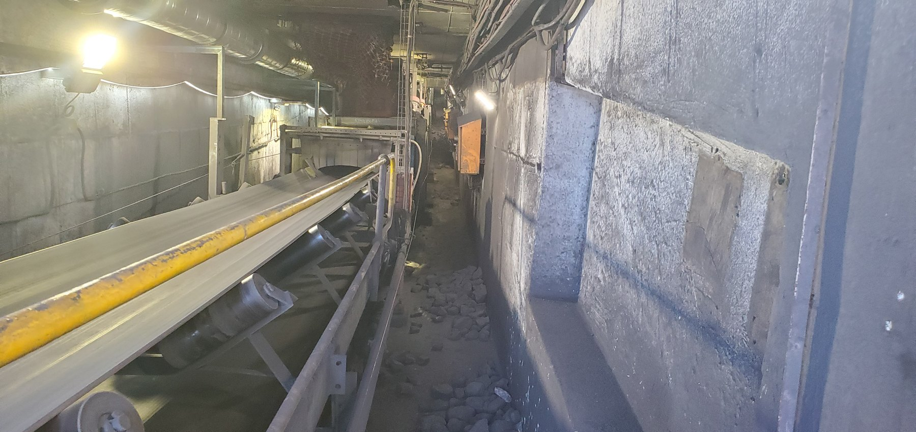  W10-REF-010 — long tunnel view establishing the confined topology and restricted access. |   W10-REF-002 — principal coarse/mixed-product consequence in the access route.
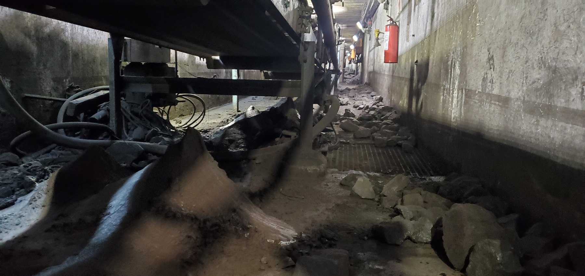  W10-REF-006 — product distributed below the conveyor around components, explaining local geometry. | 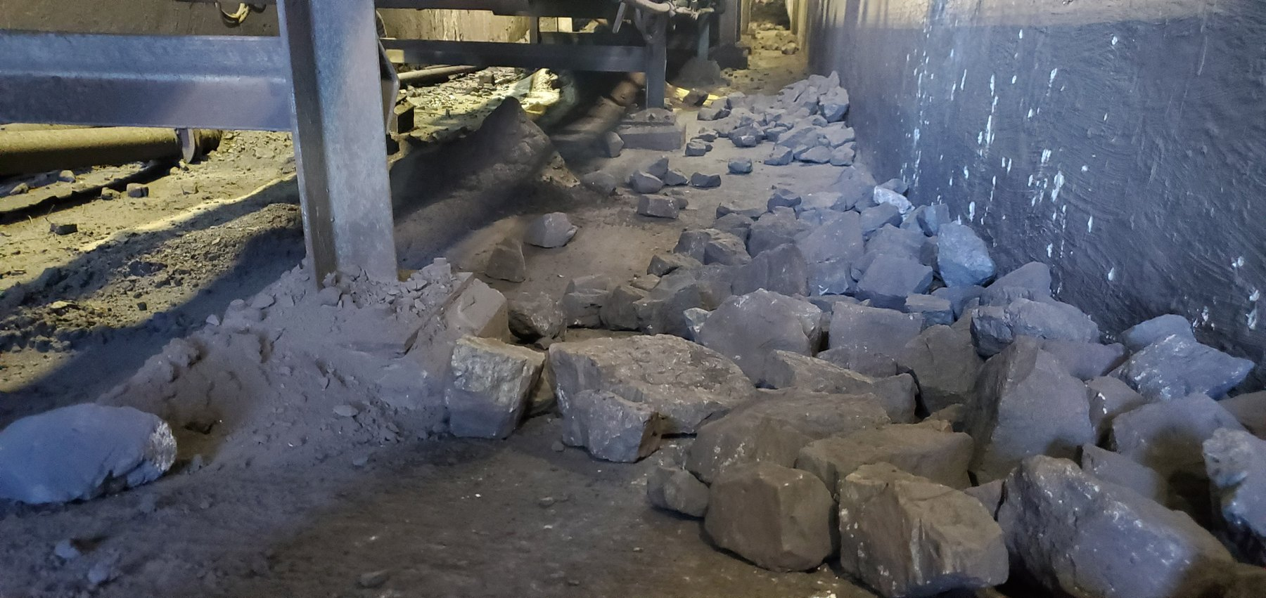  W10-REF-009 — product immediately beside support steel; useful context for local side-containment feasibility.
OBSERVATION | Coarse/mixed product has escaped the intended carrying path and accumulated in a confined access tunnel.
ENGINEERING ASSESSMENT | The exact initiating mechanism remains unresolved. A side-containment barrier/rail is therefore a secondary working concept, not a substitute for checking loading, troughing, tracking and local geometry.
RECOMMENDED NEXT ACTION | Complete dimensional/tracking/clearance checks and assess a local side-containment concept that remains clear of the belt in normal operation and does not create trapping, wear, access or safety risks.

13 Sample Conveyors — Product Size, Feed and Limited Carrying Width
Sample Conveyors 2 and 3 show another form of coarse-product containment pressure. Large product occupies a substantial proportion of the relatively narrow belt carrying width. The first engineering question is therefore whether incoming quantity and product-size distribution are appropriate for the usable belt width and feed arrangement.
CONTROL HIERARCHY | 1. Understand/control the feed and product size/quantity. 2. Verify/correct belt tracking and tension. 3. Add secondary side containment where appropriate after the first two conditions are addressed.

13.1 Sample Conveyor 2
At Sample Conveyor 2 the loading/containment concern is directly supported, but significant mistracking is not visually established. The evidence does not prove quantitative design-capacity overload or identify the final feed-control method.
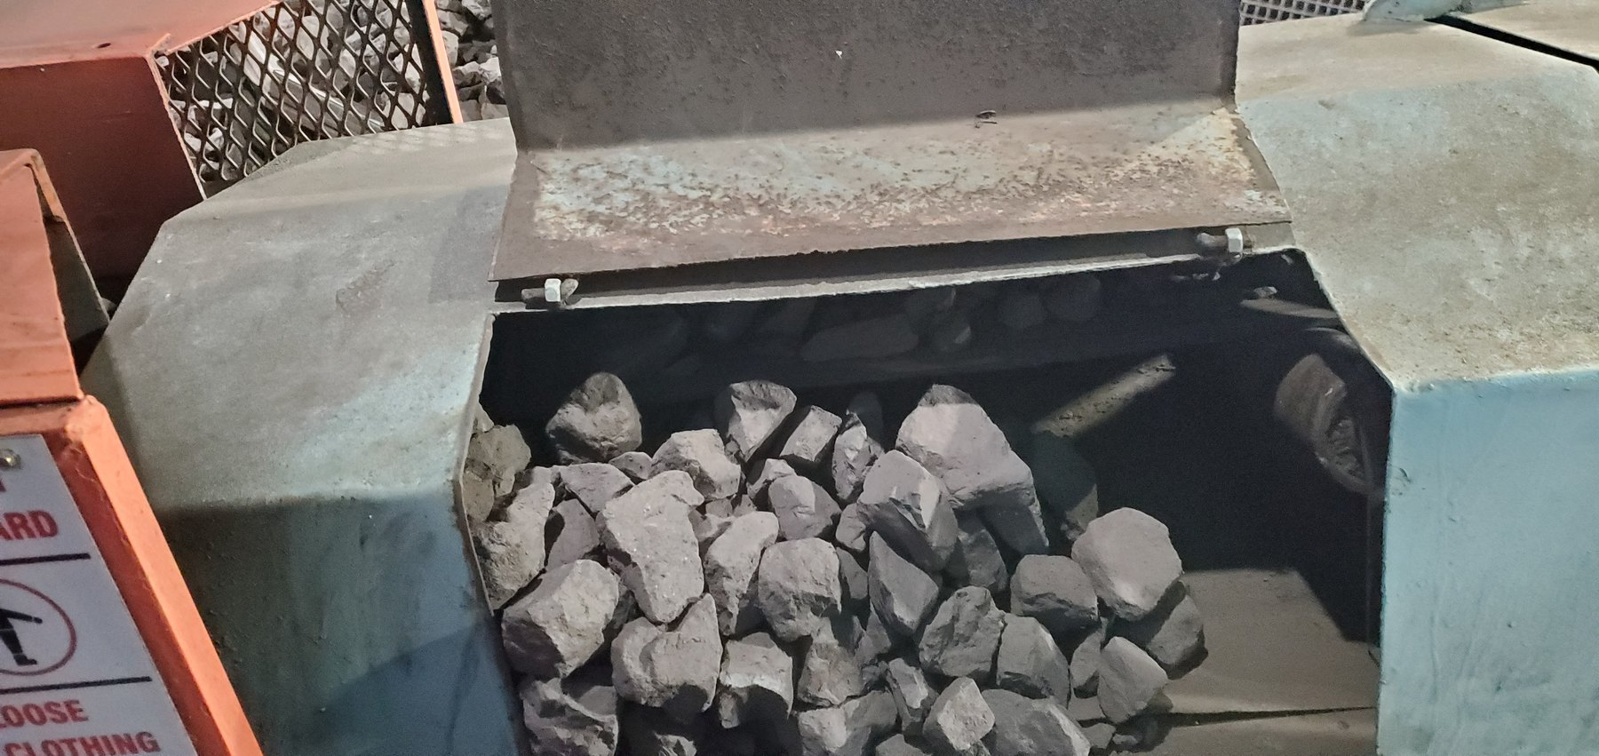  LoadoutStationSample2-REF-004 — coarse product occupying a substantial proportion of the narrow belt width. | 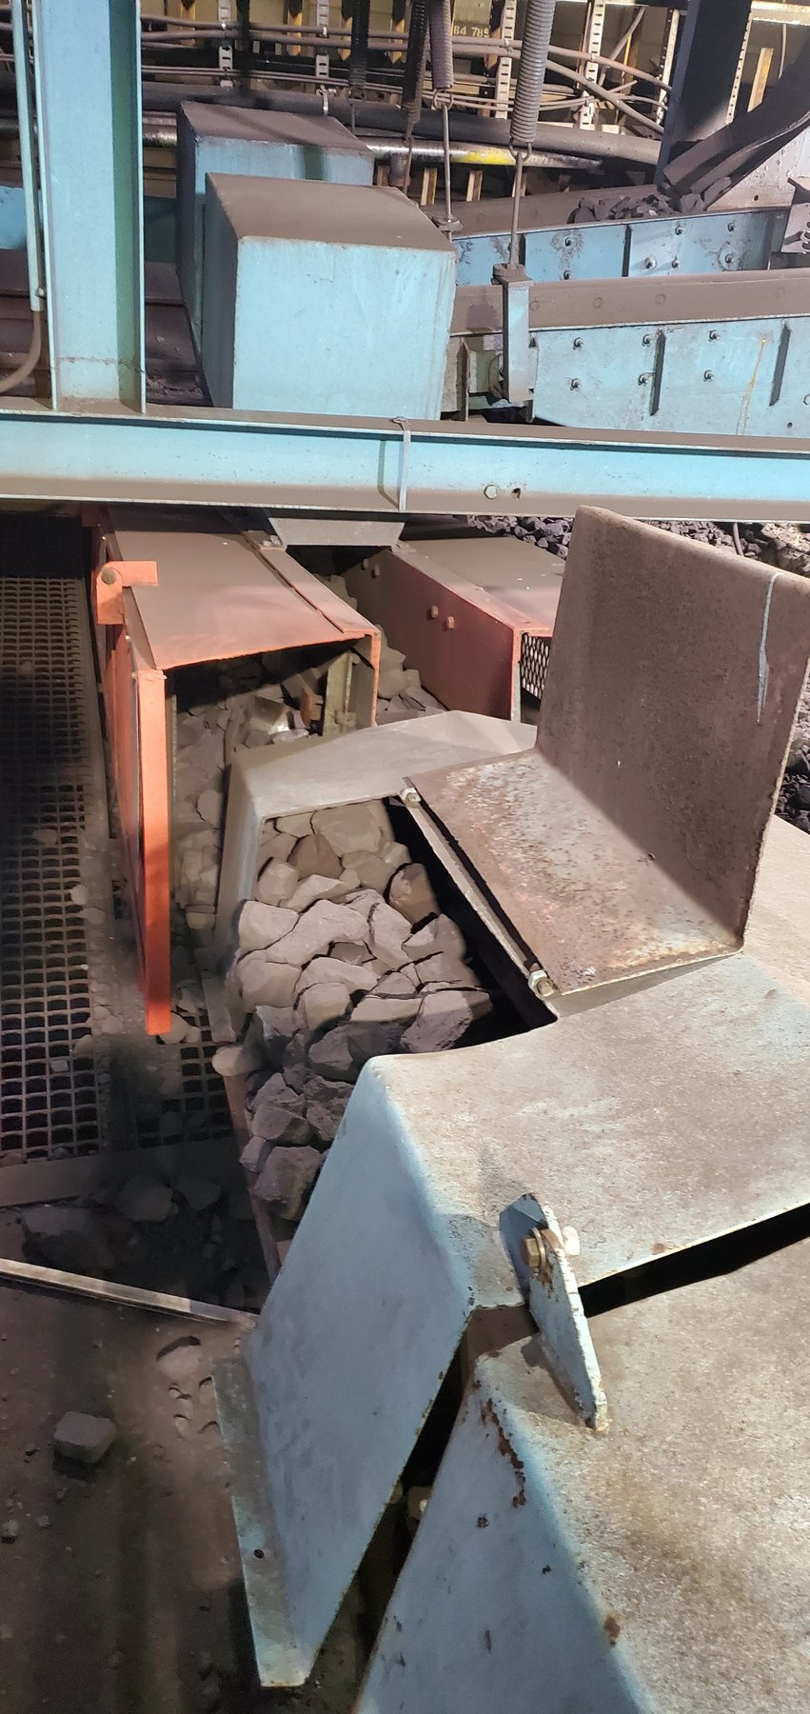  LoadoutStationSample2-REF-006 — product accumulated through/around the local enclosure and outside the intended carrying path. | 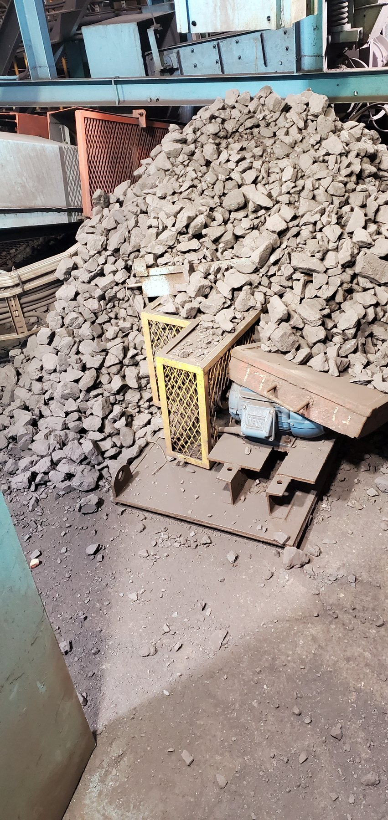  LoadoutStationSample2-REF-001 — extensive surrounding lump-product accumulation.
The recommended response is to verify feed rate/quantity, product-size distribution and usable belt width before specifying secondary containment. Tracking should still be checked during representative operation, but the present still evidence should not be used to label Sample 2 as a confirmed mistracking case.

13.2 Sample Conveyor 3
Sample Conveyor 3 combines the same narrow-belt/product-size containment pressure with visually supported lateral belt offset/mistracking. The offset magnitude remains unmeasured and the photographs do not establish the mechanical root cause.
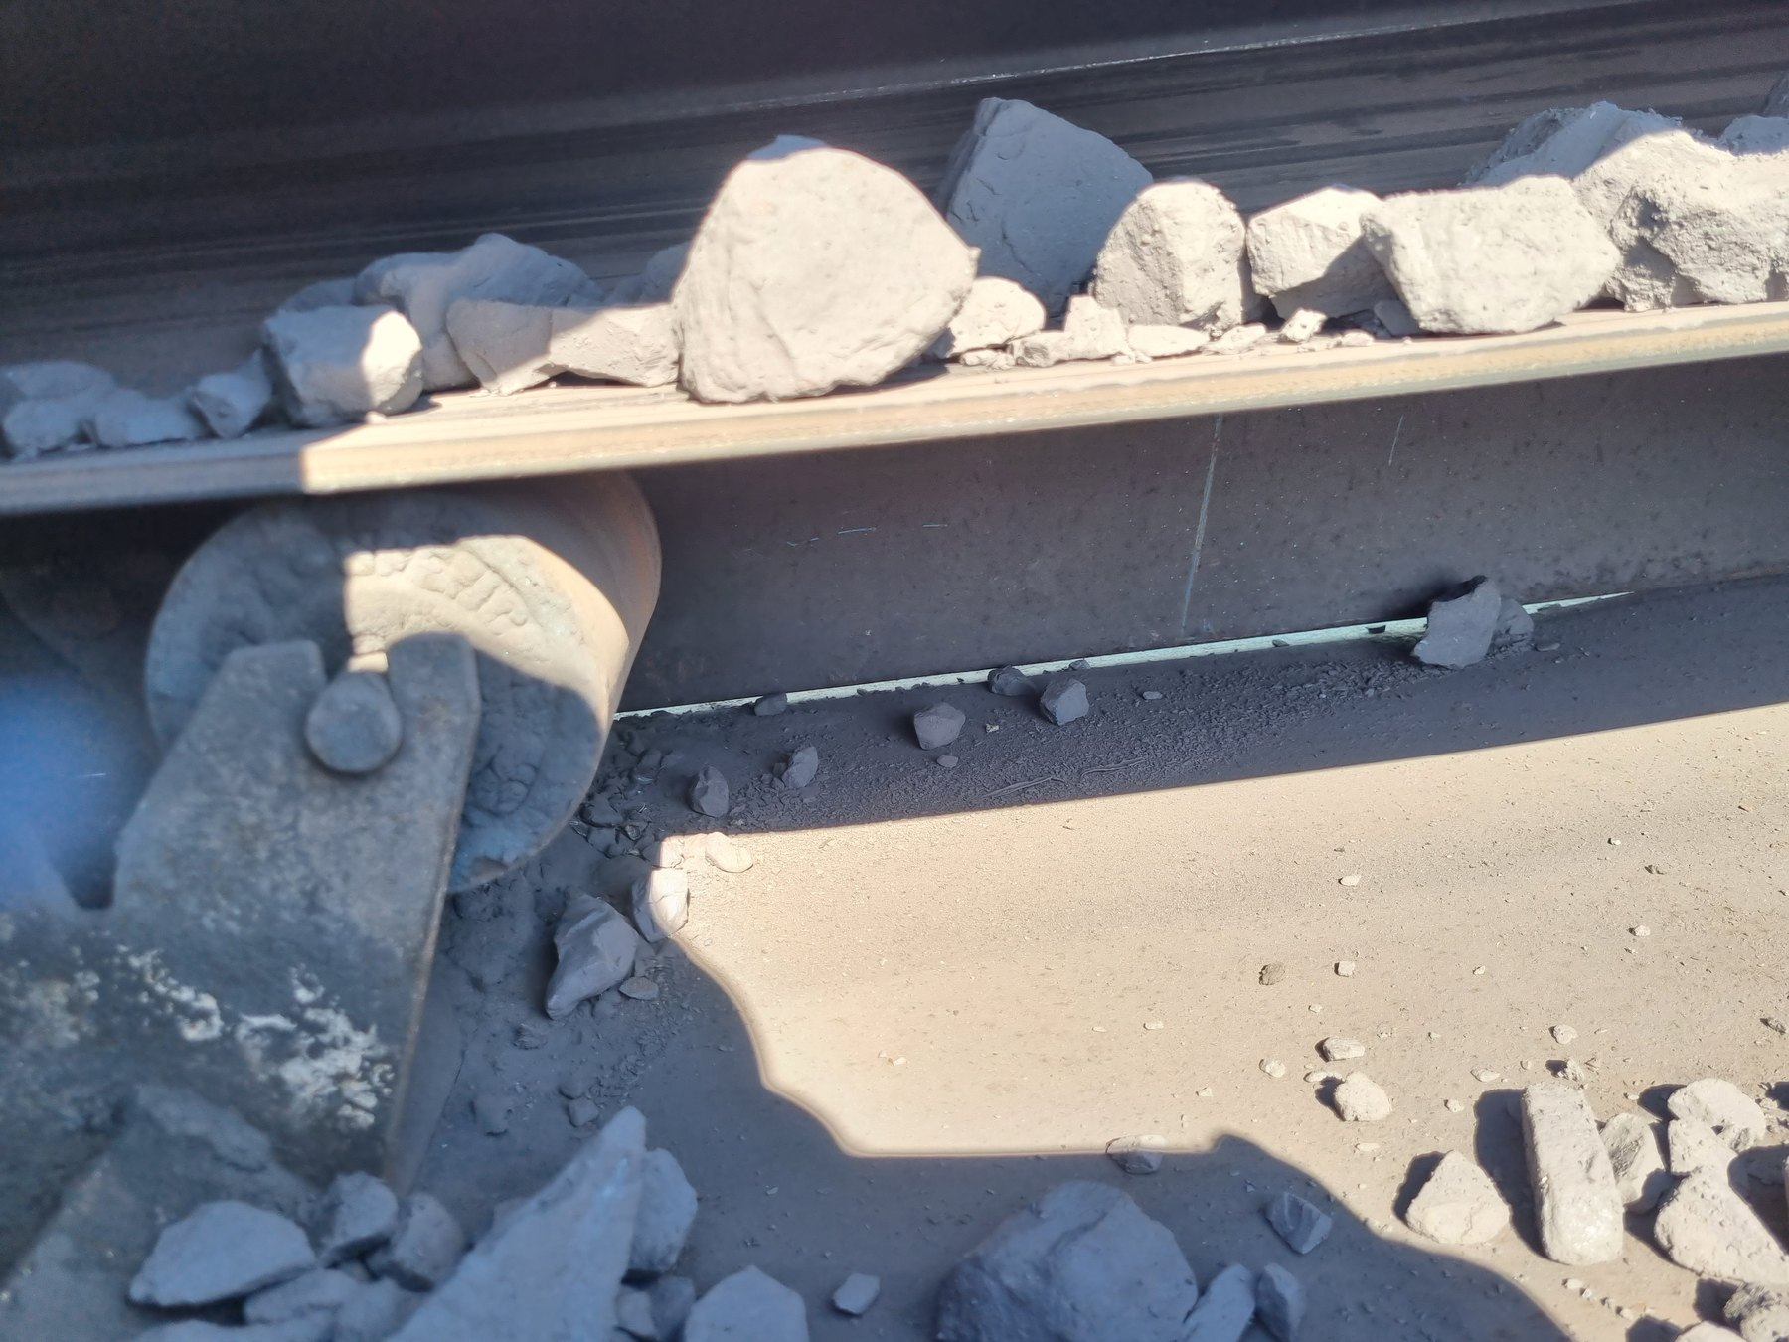  LoadoutStationSample3-REF-005 — large lumps occupying much of the available narrow belt width. | 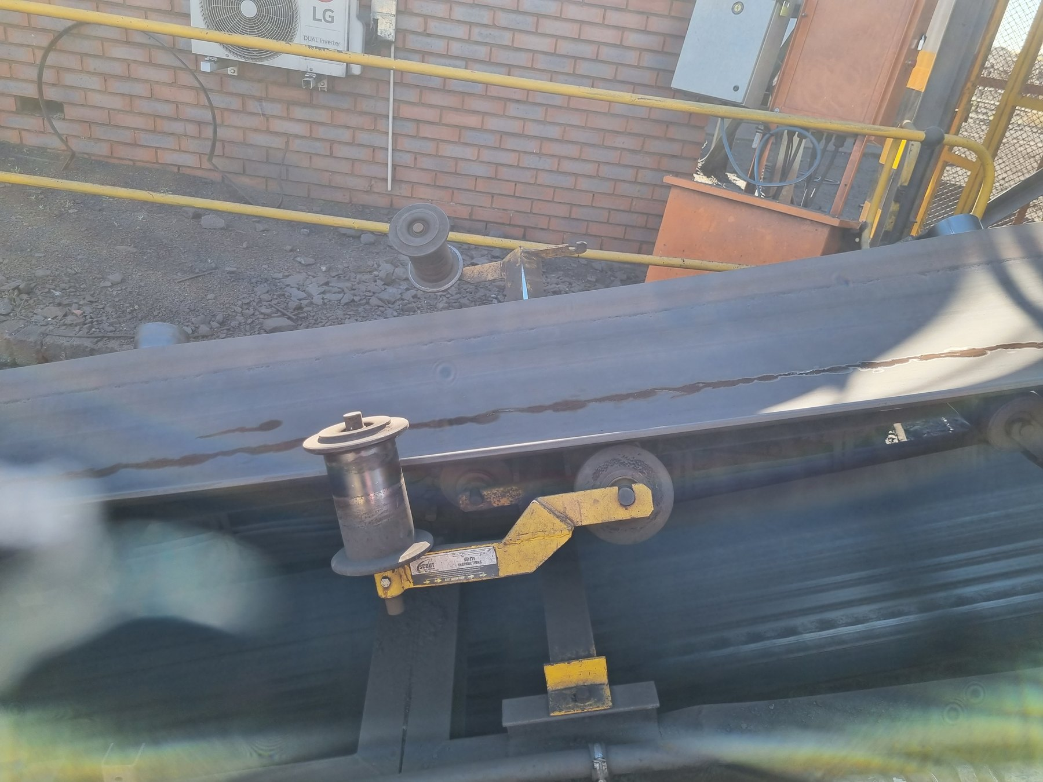  LoadoutStationSample3-REF-013 — strongest still supporting lateral belt offset relative to the training/guide arrangement.
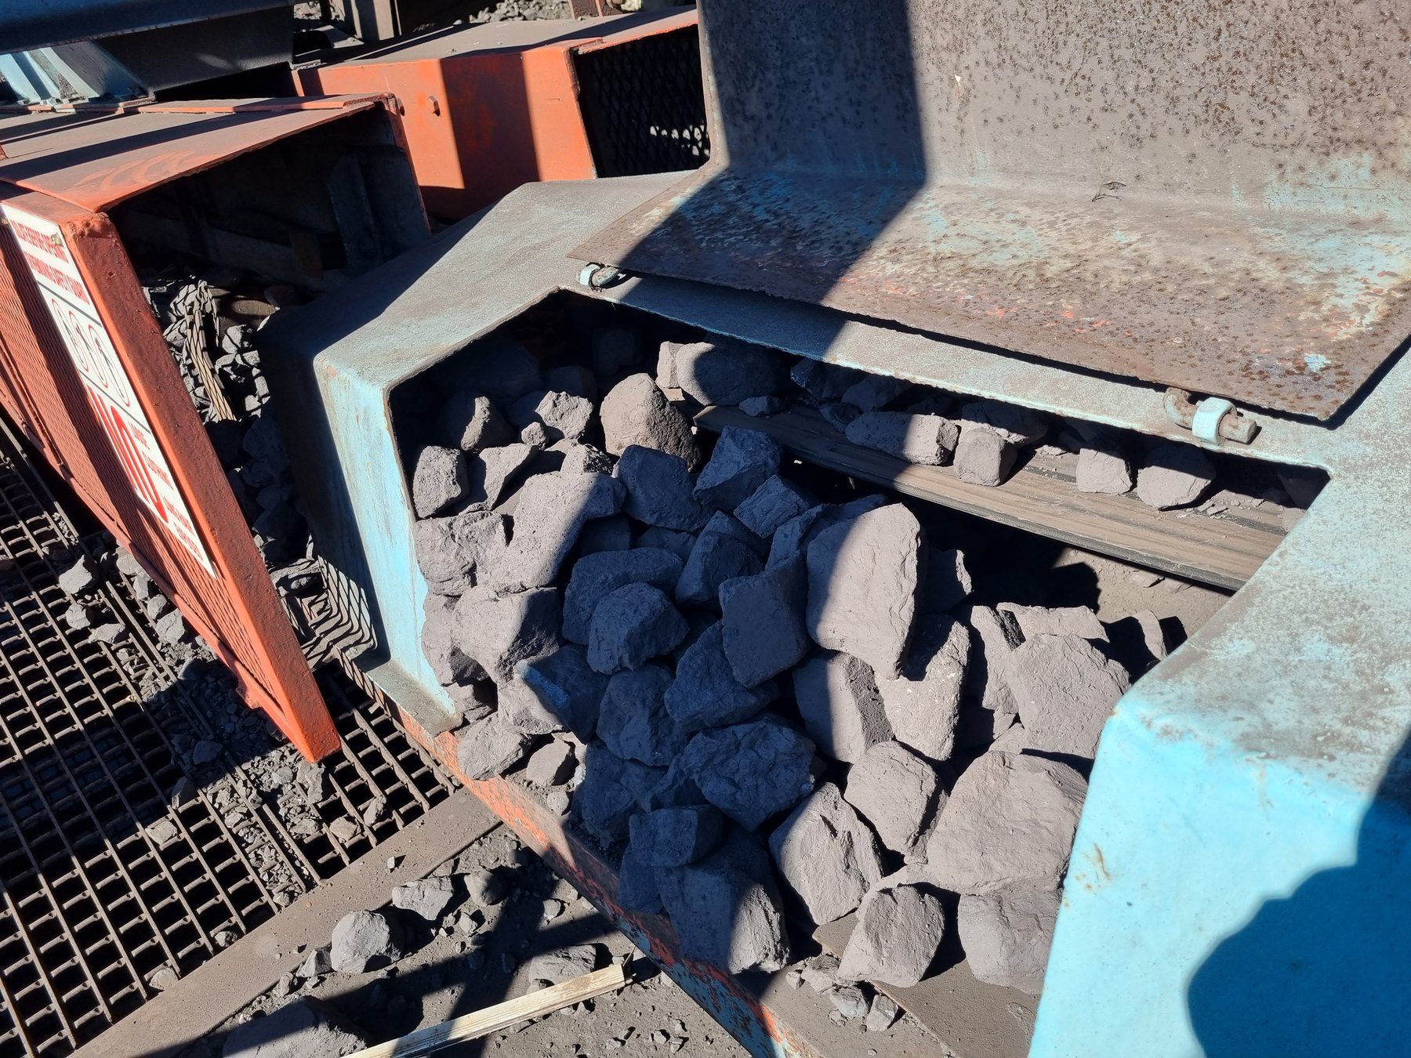  LoadoutStationSample3-REF-002 — coarse product accumulated around/outside the intended belt path. | 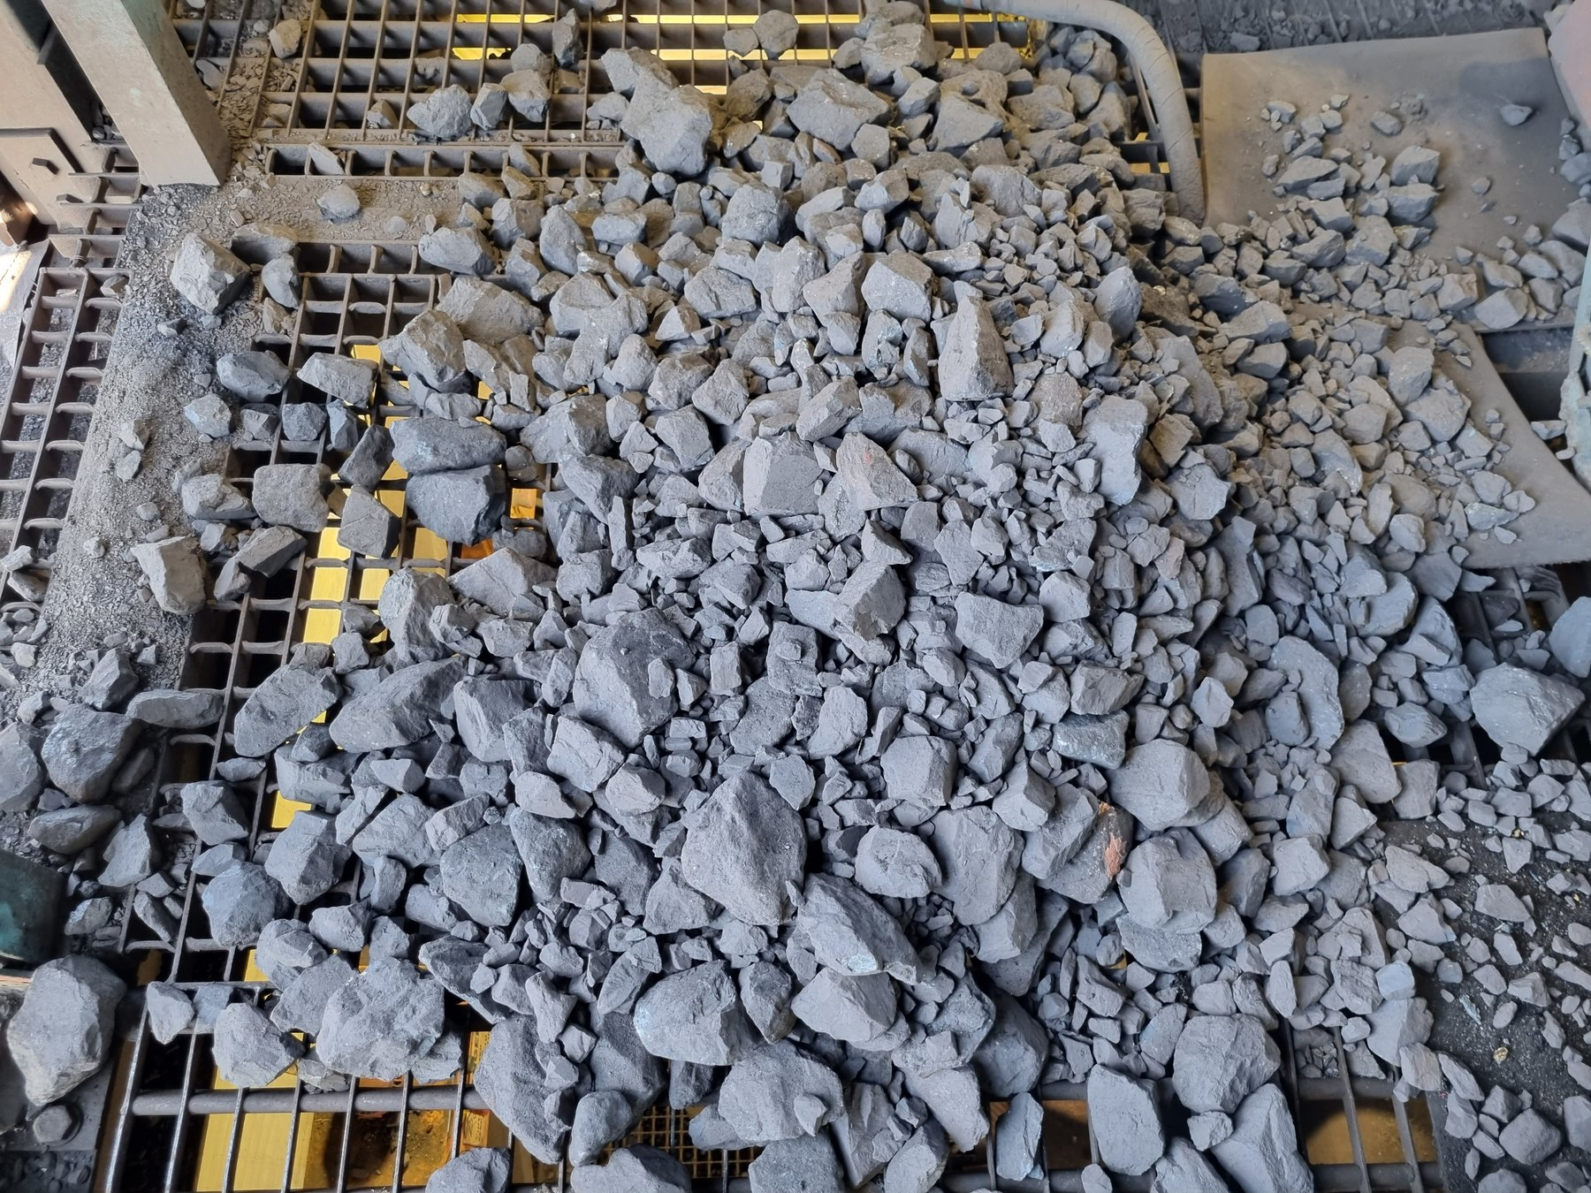  LoadoutStationSample3-REF-012 — extensive mixed-size accumulation on surrounding grating/access.
OBSERVATION | Product-size/available-width pressure and significant surrounding spillage are visually established; lateral offset/mistracking is also visually supported.
ENGINEERING ASSESSMENT | The evidence does not justify a measured percentage or millimetre offset, and it does not prove whether head/tail alignment, tension, trapped material or another mechanical condition is the root cause.
RECOMMENDED NEXT ACTION | Control feed/load, measure and correct tracking/alignment under representative operation, then develop secondary side-containment only where required by the verified geometry.
PART VI — ALIGNMENT AND LOCAL PRODUCT-LOSS MECHANISMS

14 Belt Tracking as a Material-Containment Requirement
A carrying belt can use its full containment margin only when it remains centred relative to the supporting structure. Lateral displacement reduces usable carrying width on one side and can expose product to the edge of the carrying envelope. Tracking is therefore both a mechanical condition and a material-containment control.

15 U4 Tripper Car — Strong Local Cause-and-Effect Example
U4 provides one of the clearest local cases in which significant lateral belt offset/mistracking and one-sided product loss are both supported by the evidence. Tail-pulley misalignment was recorded during the inspection and is visually supported, but the magnitude was not measured against a fixed survey reference.
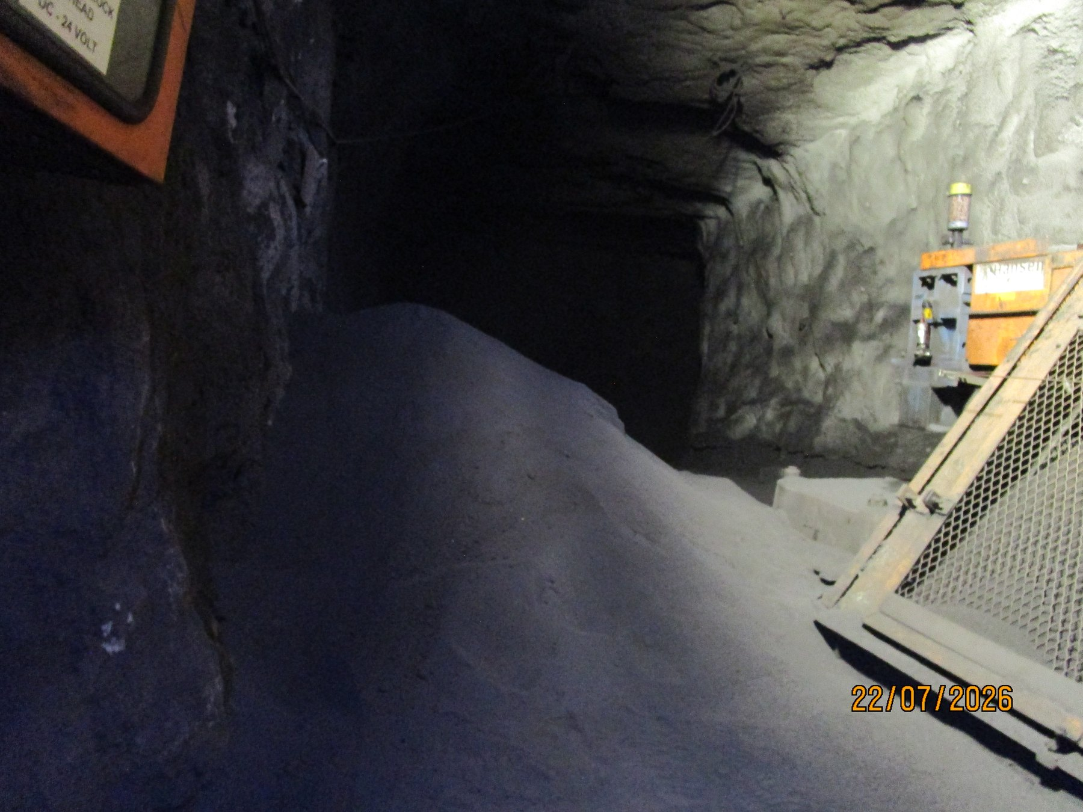  UGU4-REF-006 — principal local product-loss / mistracking context. | 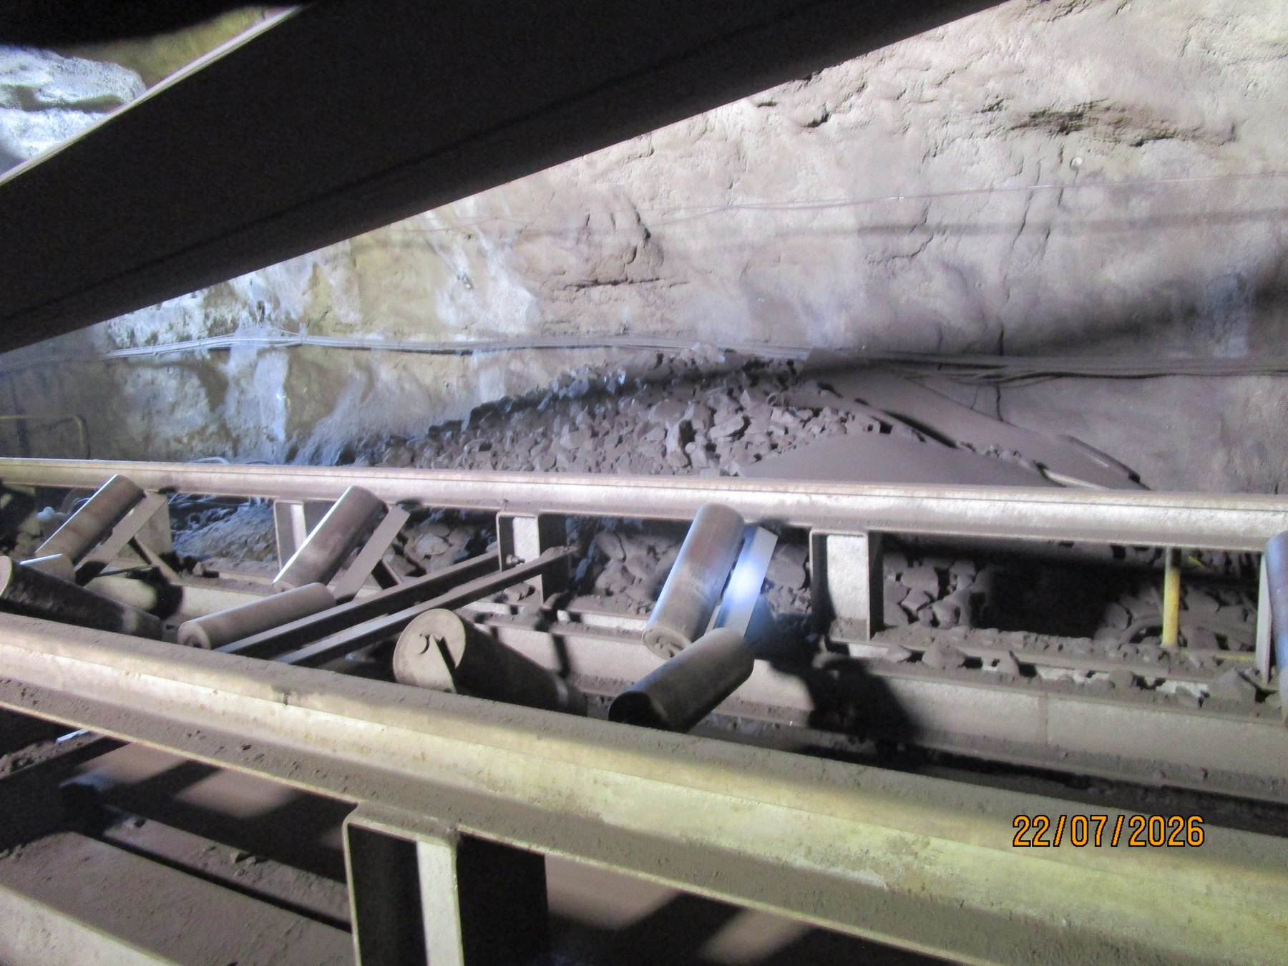  UGU4-REF-007 — significant lateral belt position and local material condition.
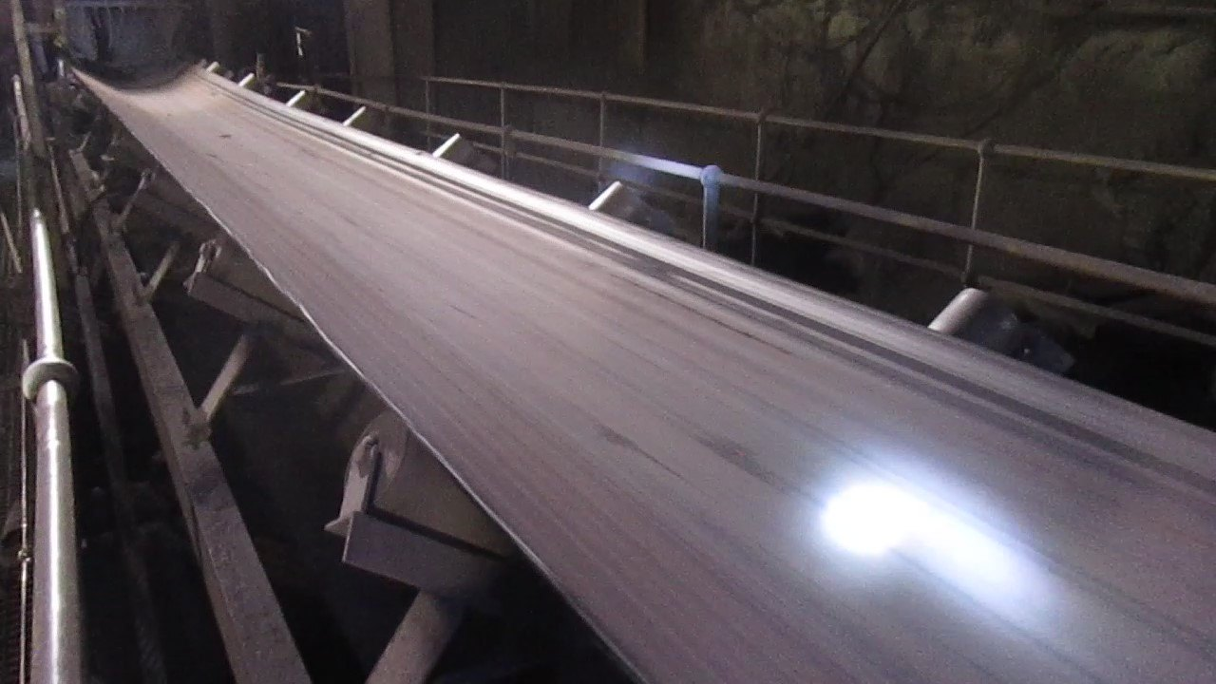  UGU4-REF-009 — supporting belt/roller relationship. | 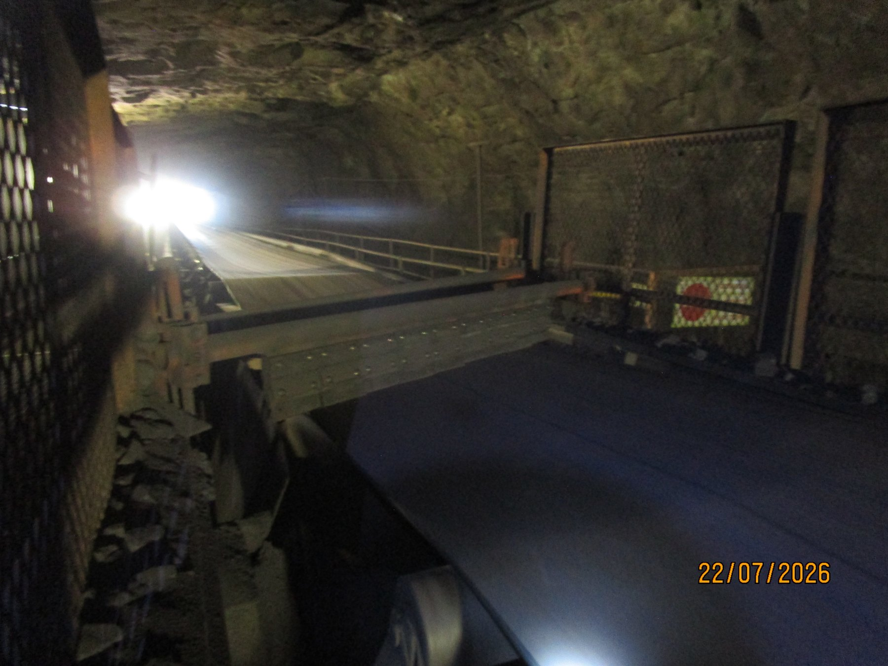  UGU4-REF-011 — strong local consequence / accumulation evidence.
OBSERVATION | Mistracking and one-side product loss are visually verified at U4.
ENGINEERING ASSESSMENT | Tail-pulley misalignment remains unquantified. The local cleaner arrangement is materially different from CV09 and must not receive a generic replicated solution.
RECOMMENDED NEXT ACTION | Quantitatively verify/realign relevant pulley geometry, check tracking through representative operation and full tripper travel, and assess the U4 cleaner/containment configuration separately.

16 L3 — Alignment Concern Without Proven Solid-Product Causal Chain
L3 is included deliberately as a contrast to U4. The tail-end offset is supported by the evidence, but the current record does not establish that the offset is causing significant solid/lump-product loss. The fines/carryback condition should therefore be reported separately from the alignment concern.
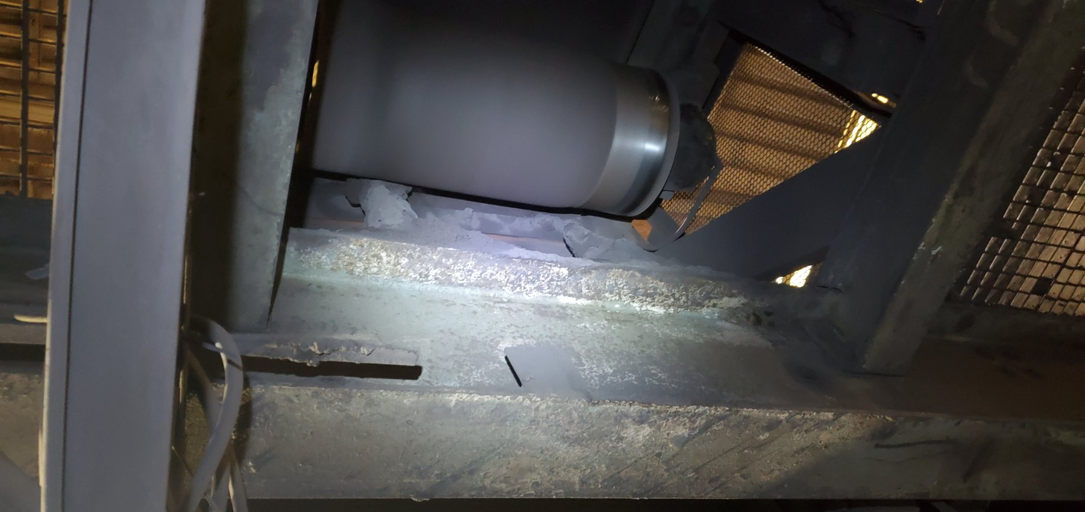  LoadoutStationL3-REF-001 — tail-end asymmetric belt/pulley relationship supporting the recorded offset; quantitative alignment measurement remains required. | 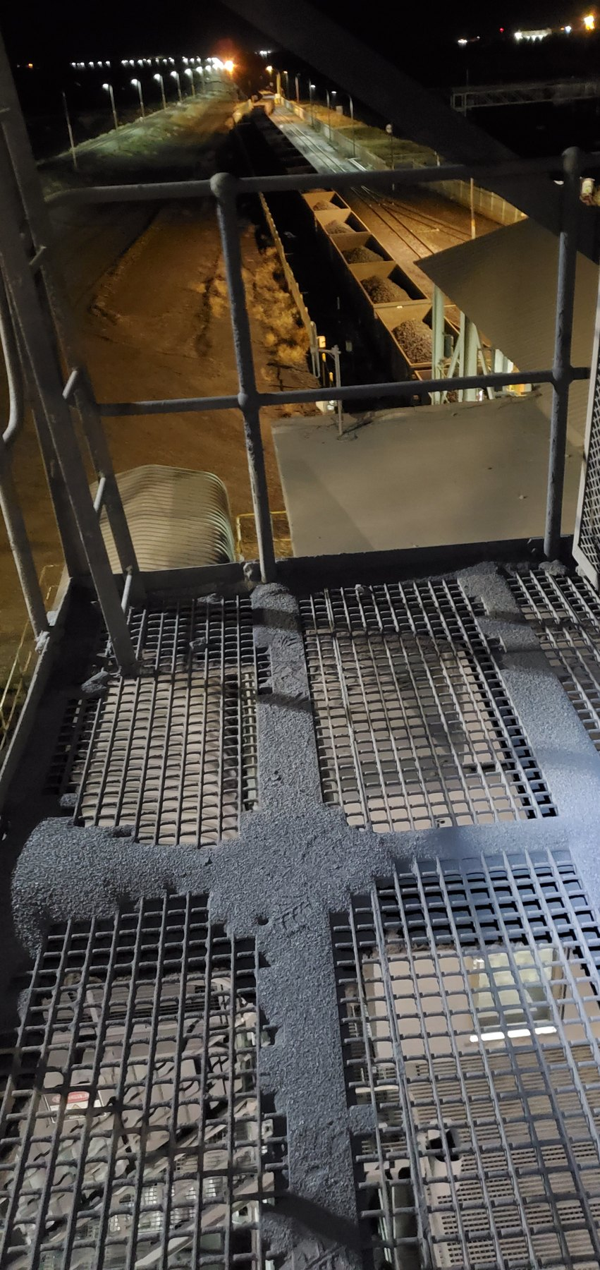  LoadoutStationL3-REF-007 — fine-material accumulation on guarding/adjacent structure.
EVIDENCE DISCIPLINE | Similar-looking alignment conditions do not automatically receive the same causal conclusion. U4 has a supported one-side product-loss relationship; L3 remains an alignment corrective-action item with a separate fines consequence.
PART VII — WATER, WET FINES AND STRUCTURAL CONSEQUENCES

17 Water as a Material-Transport and Deterioration Mechanism
Water introduces a different containment problem. When process or cleaning water escapes the intended envelope, it can mobilise fines, create slurry, spread contamination away from the source, increase slip/housekeeping burden and repeatedly wet surrounding equipment and structures.
Not every wet deposit proves the same water source. The report therefore distinguishes directly observed process-water escape from locations where water is visible but the source remains unresolved.
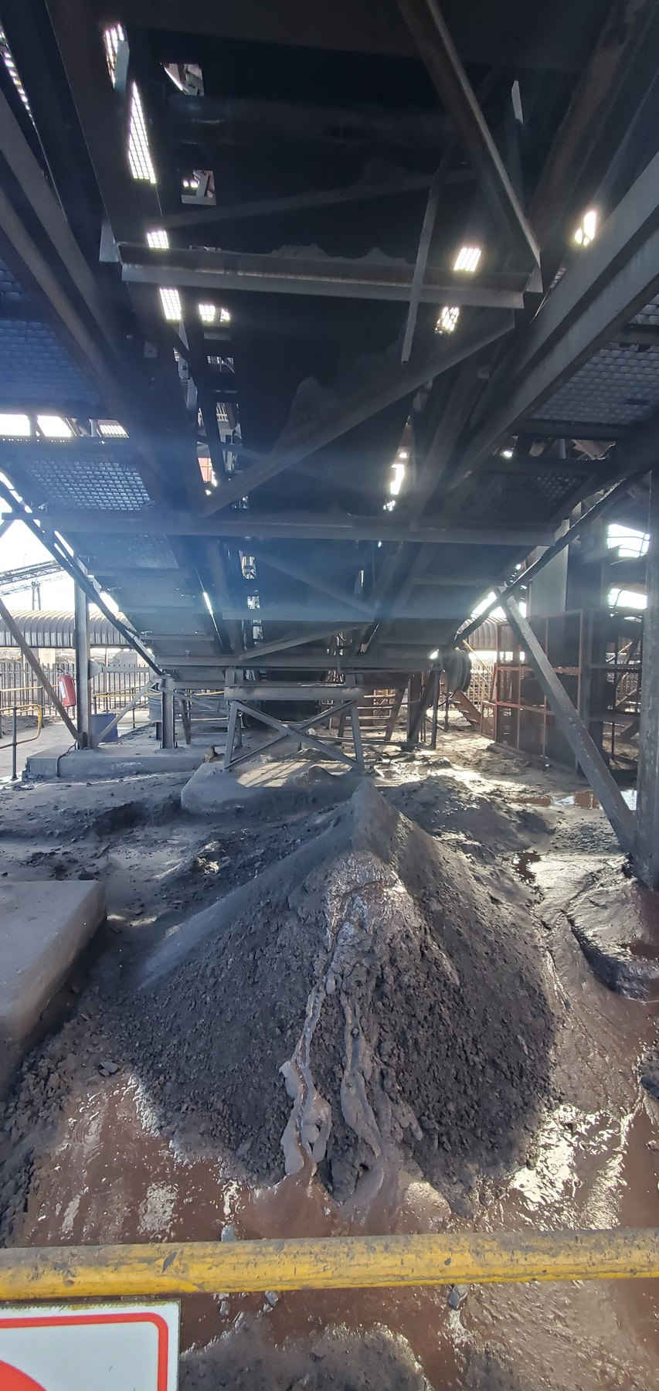  CV01-REF-003 — principal wet-fines/slurry consequence with pooled water/slurry; exact water source unresolved. |   CV04-REF-002 — saturated wet-fines/slurry with visible wet fallout/droplets. | 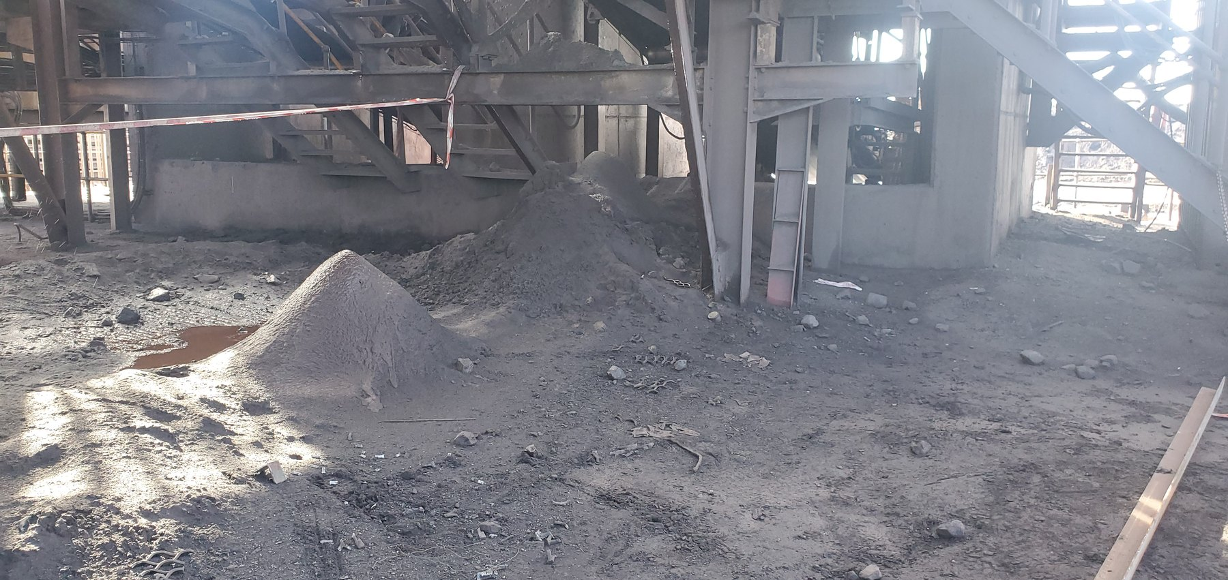  CV04-REF-005 — wider extent of multiple fines piles supporting the widespread CV04 condition.

18 Screens — Confirmed Water Escape / Separate Structural Story
The Screens evidence contains three related but distinct stories: active water loss of containment, severe corrosion/section deterioration, and physical cut-outs/notches in support members. These conditions should not be collapsed into one unsupported causal statement.
Video evidence directly confirms active water escaping the operating screen/chute environment. The exact equipment-level escape mechanism could not be safely established during operation and therefore requires a controlled shutdown inspection before a detailed modification is specified.
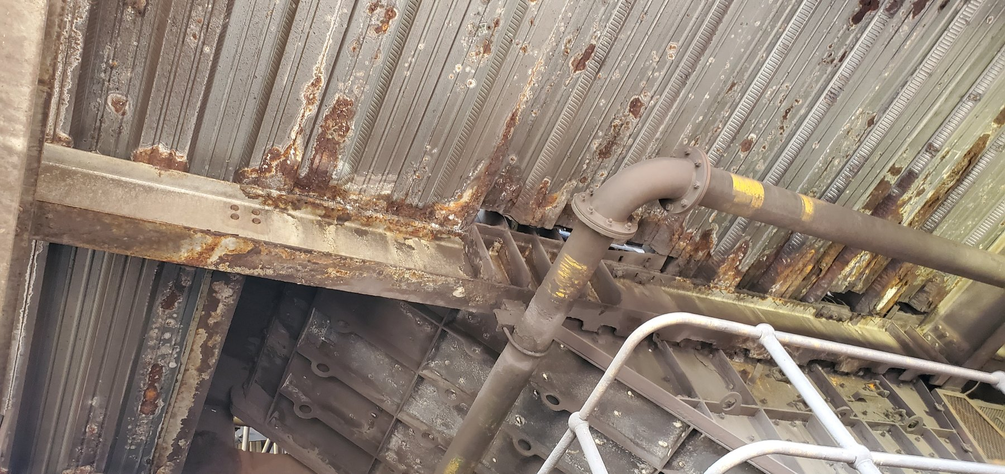  Screen-REF-003 — wider screen/chute orientation and structural zone. | 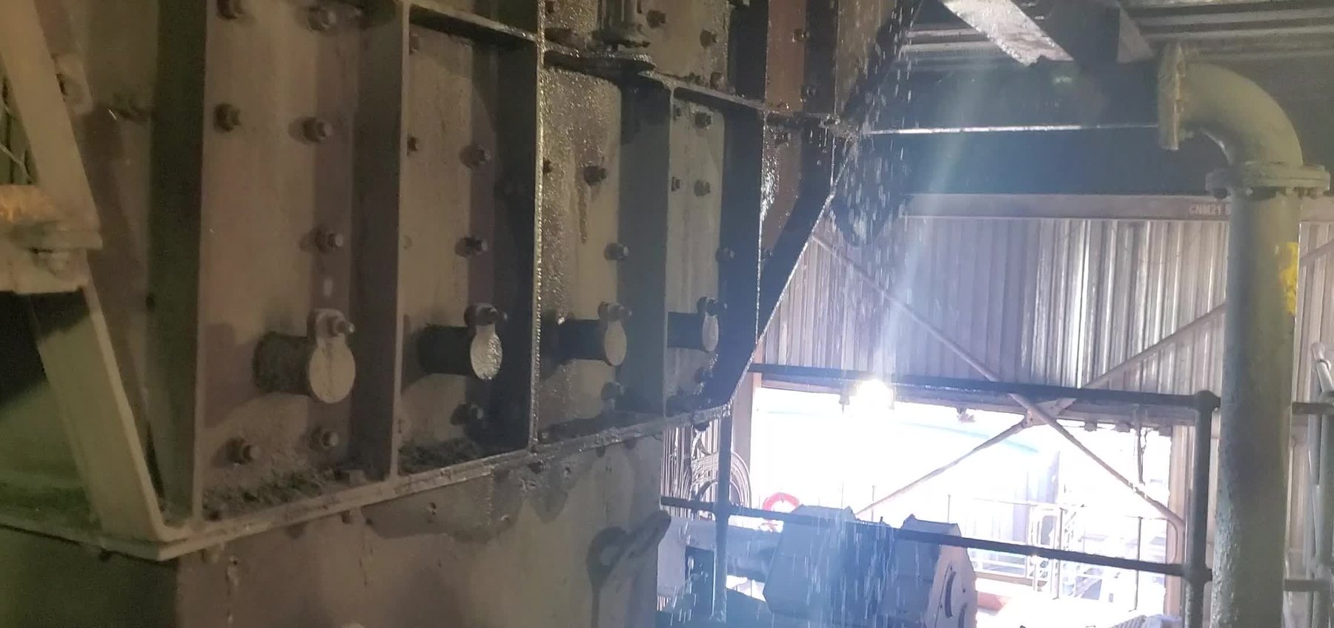  Screen-REF-016 — representative frame from inspection video showing active water spray/droplets escaping containment.
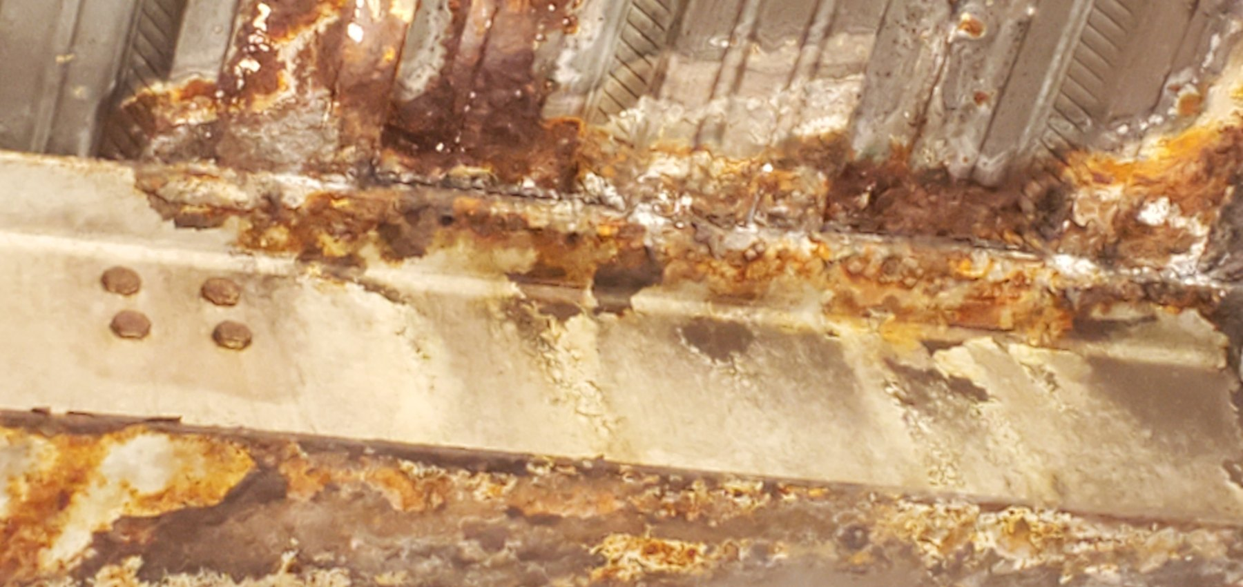  Screen-REF-004 — principal close corrosion/deterioration evidence. | 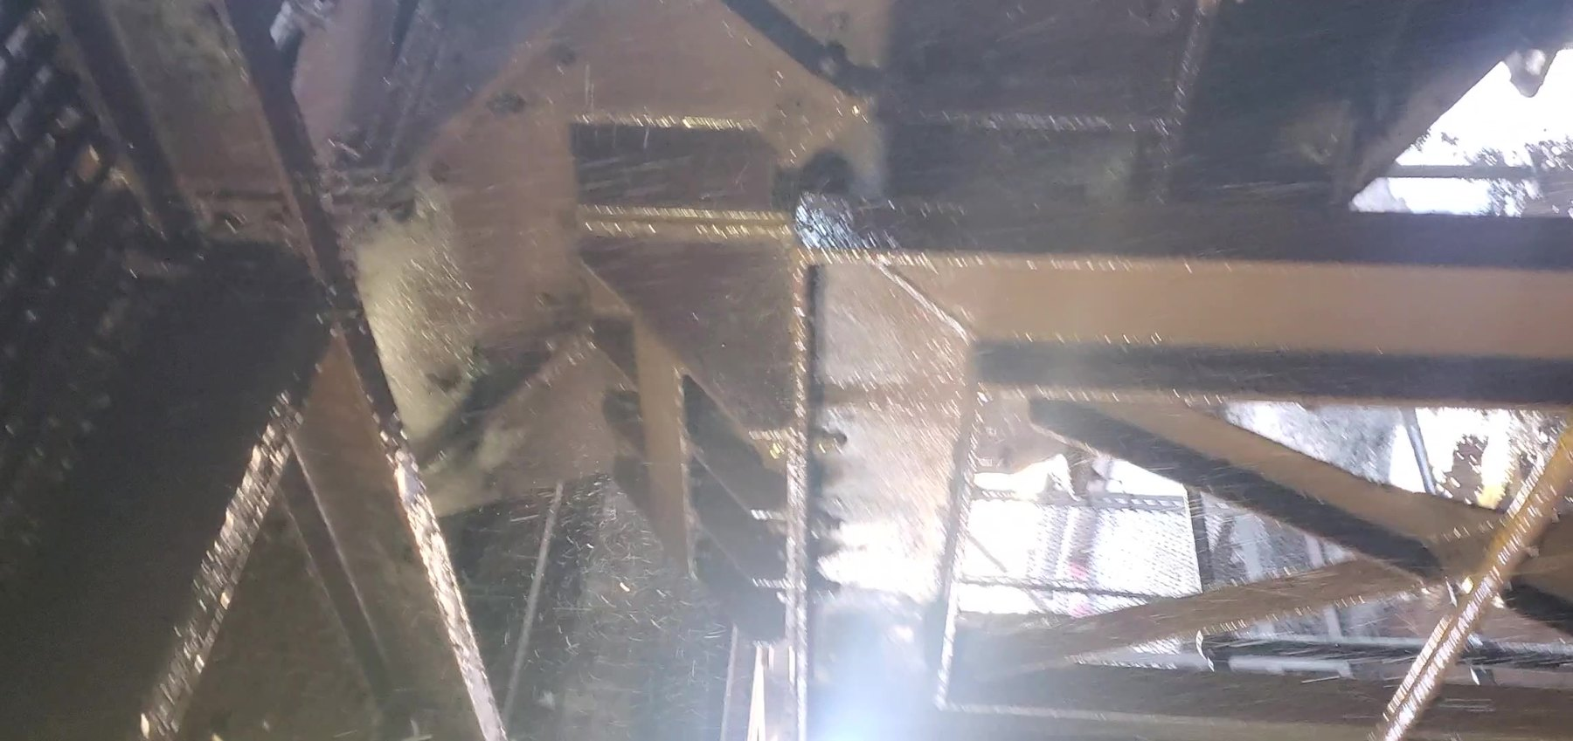  Screen-REF-017 — representative frame from inspection video showing wider substantial water spray/runoff and repeated wetting.
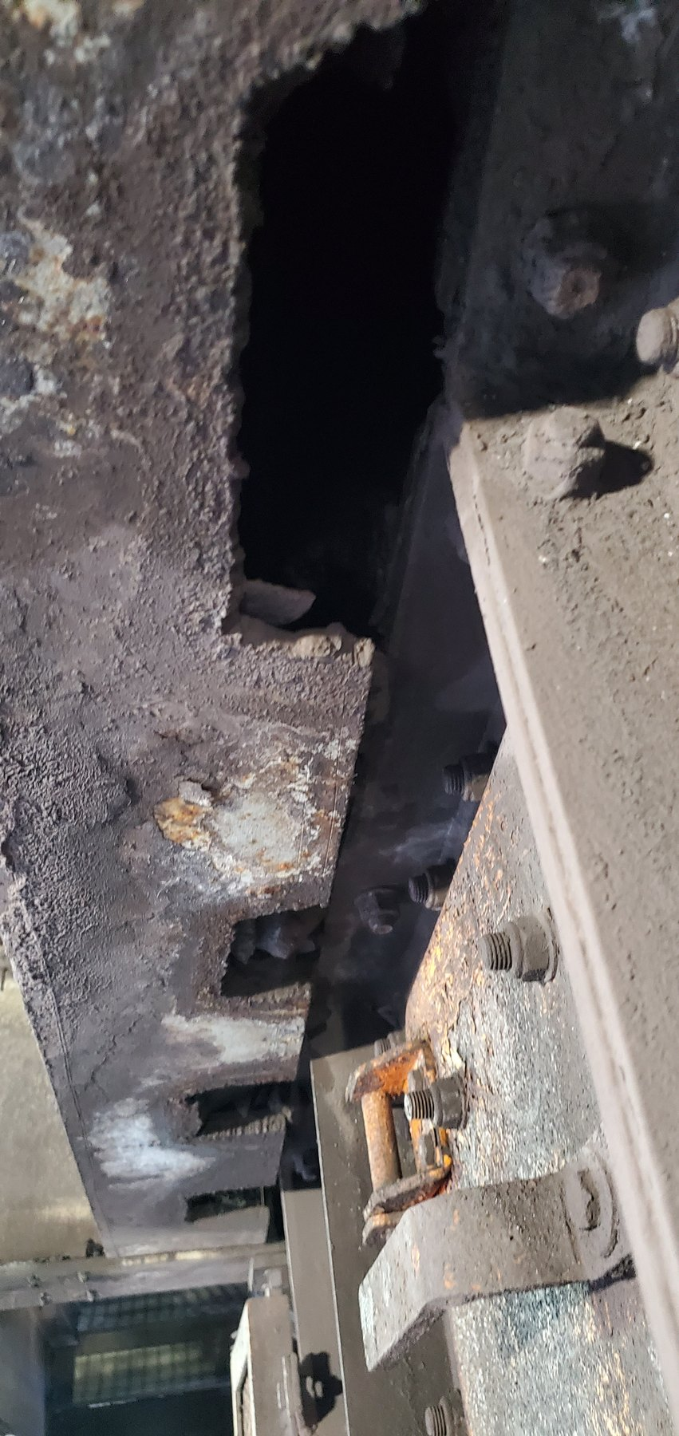  Screen-REF-006 — multiple support-member cut-outs/notches. | 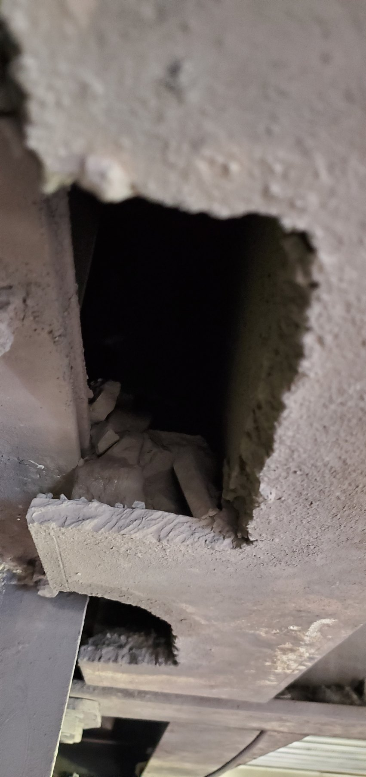  Screen-REF-010 — close evidence of a substantial support-member cut-out.
OBSERVATION | Active water escape is directly verified. Severe corrosion/deterioration and physical support-member cut-outs are also directly visible.
ENGINEERING ASSESSMENT | The equipment-level water source/escape mechanism remains unresolved. The reason for the cut-outs and the remaining structural capacity are not established. Water should not be asserted as the cause of every structural defect.
RECOMMENDED NEXT ACTION | Complete a safe shutdown inspection to identify the water escape mechanism and perform a formal structural assessment of the affected support members, including the cut/notched and corroded sections.

19 L1 — Spillage, Historical Belt Contact and Structural Deterioration
L1 contains several related but separate findings: widespread material/fines accumulation, physical evidence that the belt has previously or intermittently contacted adjacent supports, significant concrete deterioration with exposed reinforcement, and severe steel corrosion/section deterioration at more than one support location.
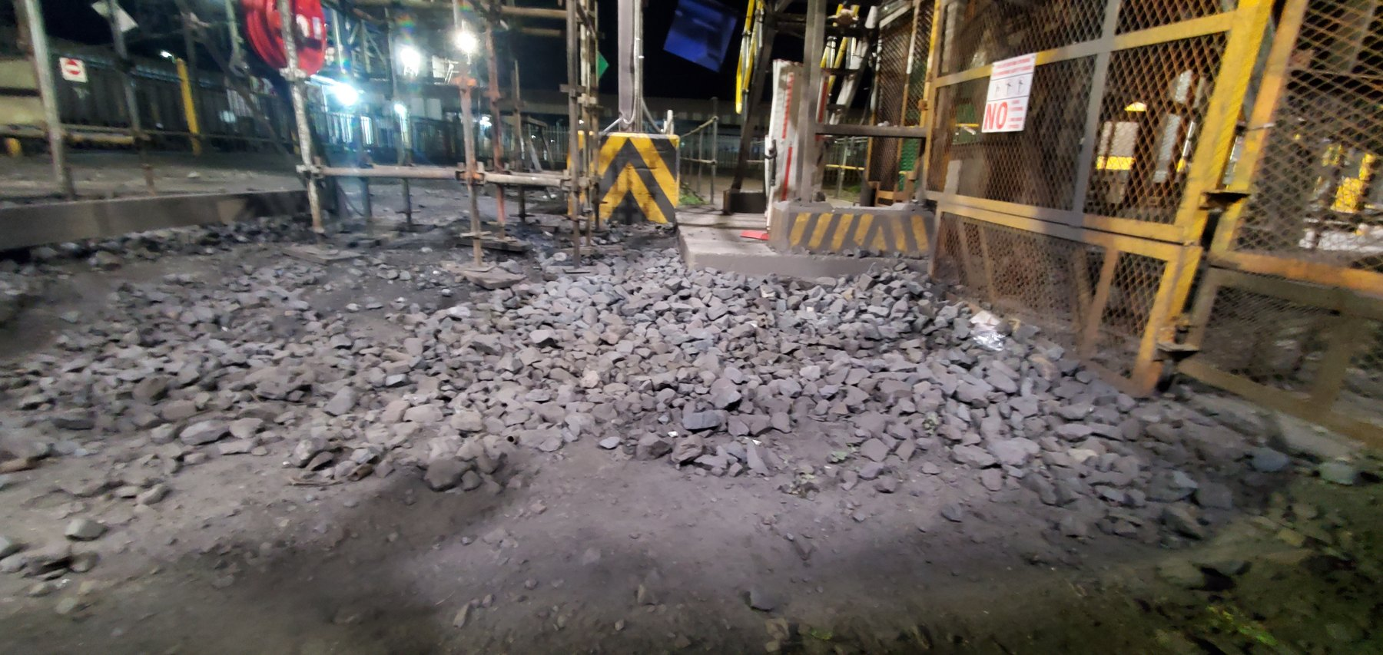
LoadoutStationL1-REF-013 — principal evidence of extensive long-term material/fines accumulation along the L1 conveyor zone.
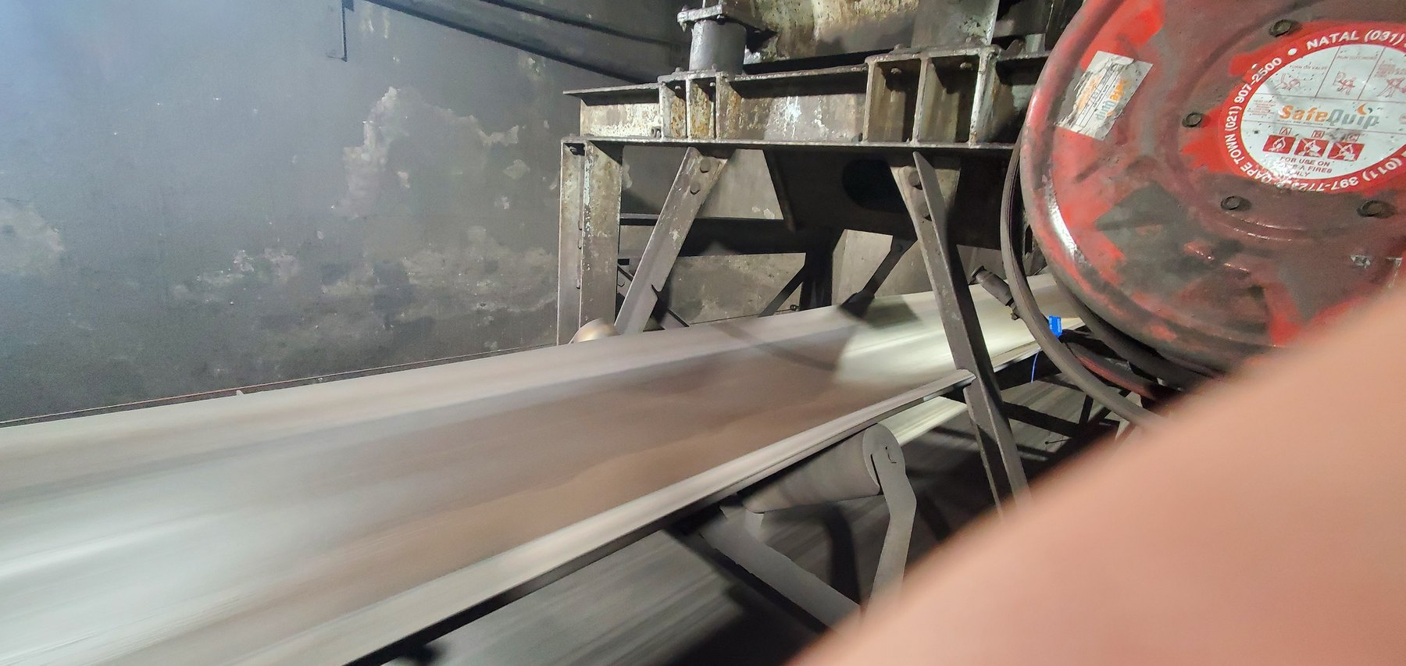  LoadoutStationL1-REF-007 — historical wear slots beside a currently clear running belt; establishes prior/intermittent contact without proving continuous present contact. | 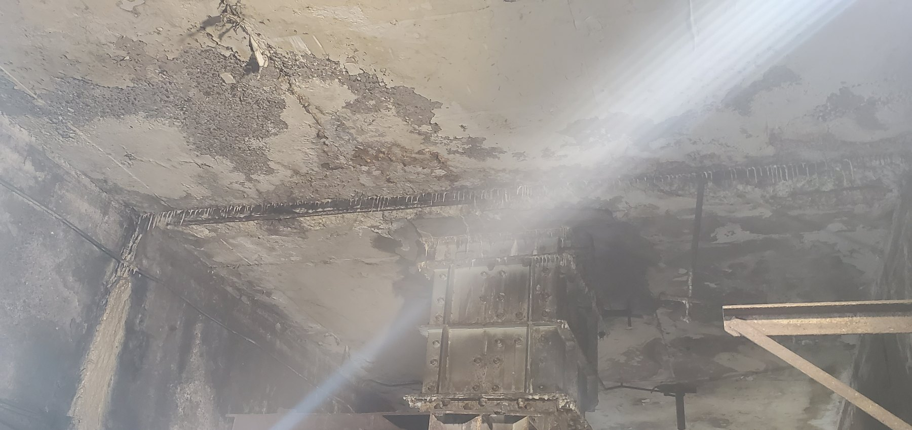  LoadoutStationL1-REF-004 — location/context for concrete deterioration. | 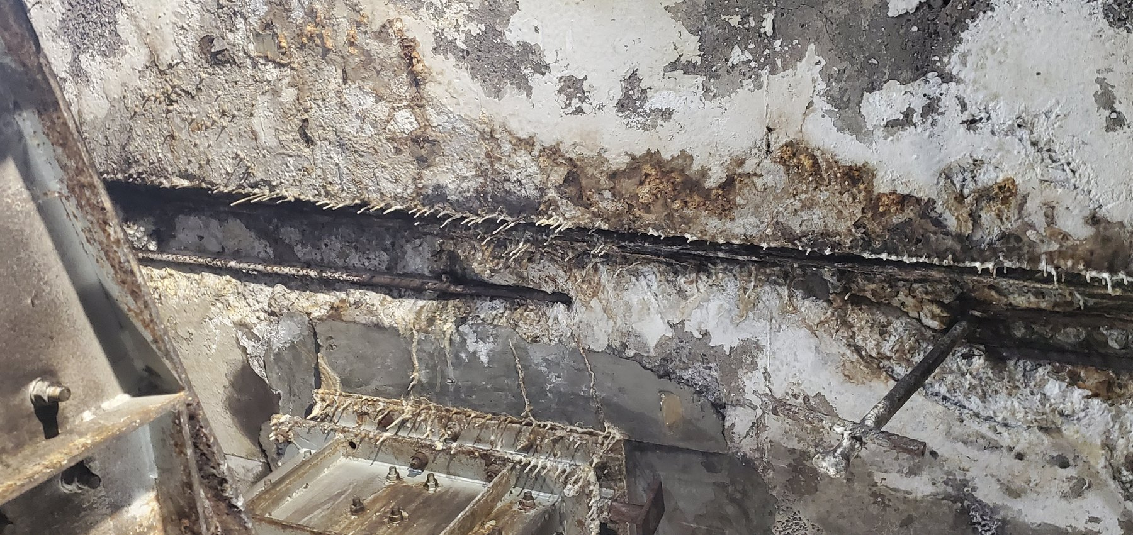  LoadoutStationL1-REF-005 — close severity of concrete loss and exposed reinforcement.
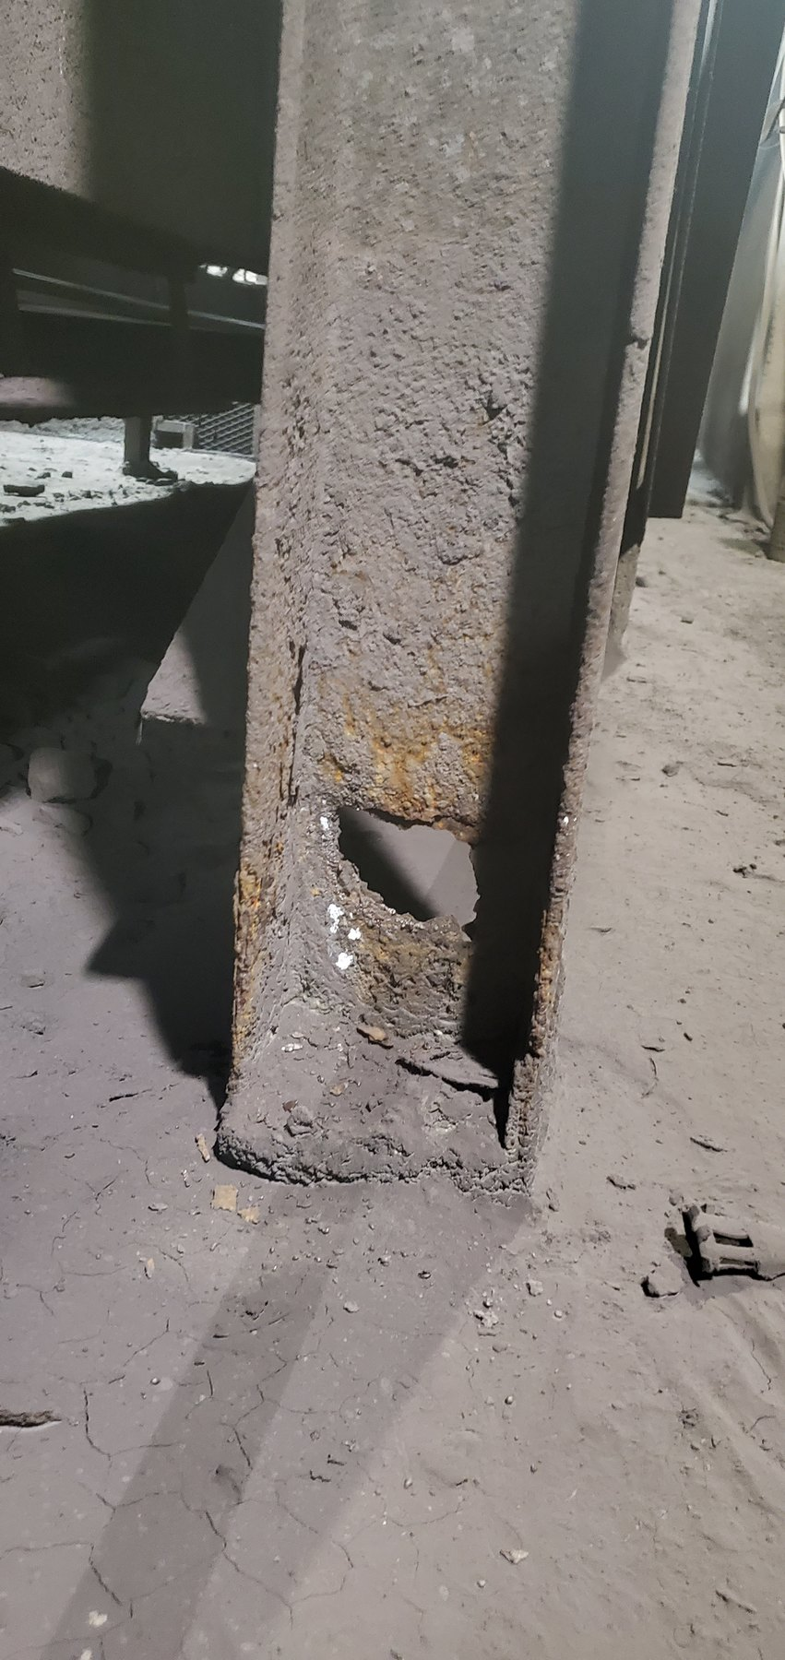  LoadoutStationL1-REF-008 — severe steel deterioration at one conveyor support location. | 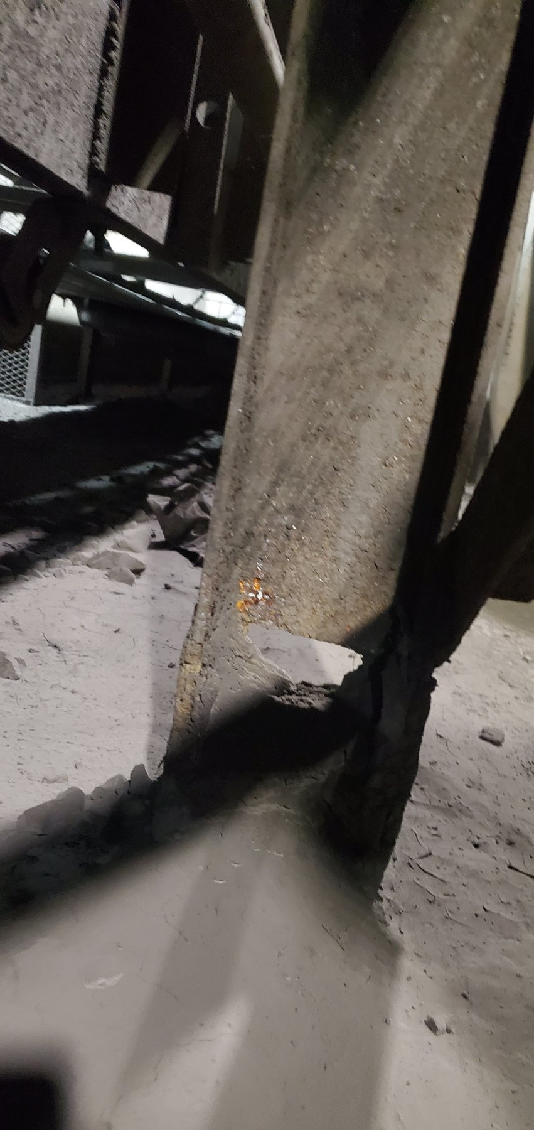  LoadoutStationL1-REF-009 — deterioration at a separate adjacent support location. | 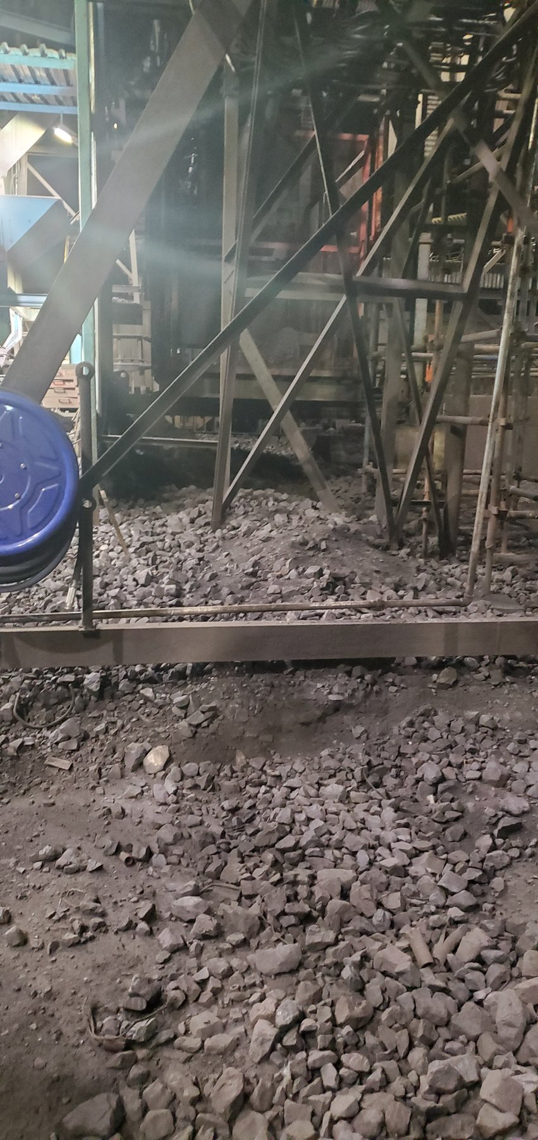  LoadoutStationL1-REF-012 — accumulation at a separate nearby location supporting spatial persistence.
OBSERVATION | Widespread accumulation, previous/intermittent belt contact evidence, concrete deterioration and multi-location steel deterioration are directly supported.
ENGINEERING ASSESSMENT | The captured running belt is clear of the worn supports, so continuous current contact is not proven. Mistracking is a probable historical mechanism for contact, while remaining structural capacity cannot be determined from photographs.
RECOMMENDED NEXT ACTION | Continue/verify tracking control; commission formal structural assessment and repair/replacement definition for the affected concrete and steel; reduce recurring product/moisture accumulation around the structure.
PART VIII — EVENT-DRIVEN AND OPERATIONAL SPILLAGE

20 Trips, Restart and Manual Product Removal
Not all spillage is chronic. Conveyor trips caused by blockages or mechanical/electrical events can leave a loaded belt that must be partially cleared before restart. Where removed product is placed beside the conveyor or at the nearest safe location, the deposit is an operationally generated secondary spillage event rather than normal carryback.
The required control is procedural: confirm the formal unloading/restart work instruction, authorised responsibility, temporary laydown/containment arrangement, and the method/timing for recovery or reintroduction of the removed product.

21 Housekeeping — Necessary but Not the Primary Solution
Manual shovelling, trolleys/wheelbarrows and water wash-down are necessary to restore access and operating condition after material has accumulated. However, repeated cleaning of the same locations indicates that the initiating source remains active.
CONTROL PRINCIPLE | Housekeeping controls the consequence. Source control should reduce the recurrence.
The report therefore treats housekeeping as a supporting operational control while prioritising engineering correction of the material-loss mechanism wherever practical.
PART IX — WHAT THE COMBINED EVIDENCE MEANS

22 Consolidated Engineering Interpretation
Taken together, the evidence does not support the idea of one mine-wide spillage defect. It supports a connected set of material-containment failures requiring one common control philosophy but several different physical solutions.
Level | Mechanism / condition | Engineering meaning
Systemic / recurring | Fines carryback; variable cleaner condition/effectiveness; incomplete containment of removed fines at some discharges. | Primary opportunity is source control at relevant discharge/cleaner locations rather than repeated downstream cleanup.
Local / geometry-specific | W10 coarse transit loss; Sample 2/3 limited carrying margin; Sample 3 mistracking; U4 mistracking; L3 offset. | Requires local feed, tracking, geometry and containment verification rather than one universal hardware solution.
Water / structural | Confirmed Screens water escape; CV01/CV04 wet conditions; Screens and L1 structural deterioration. | Water containment and structural integrity require dedicated inspection/assessment and should not be treated as housekeeping only.
Operational | Trip/restart unloading and recurring housekeeping. | Procedure and recovery controls are required, but should support rather than replace source correction.
The most important systems insight is that visible deposit location is often the consequence location rather than the initiating cause location. This is why the recommended programme is organised around material-control functions rather than simply around where the largest piles were photographed.
PART X — THE ENGINEERING CONTROL PHILOSOPHY

23 Keep the Combined Product Inside the Process
CORE PRINCIPLE | Keep the combined product — fines and coarse/lump ore — within the intended material-handling envelope throughout transit, and manage process water within its designed envelope, using controls appropriate to the specific failure mechanism and local geometry.

23.1 Fines / Carryback
- Clean the belt effectively at appropriate discharge locations.
- Maintain cleaner contact and wear compensation through service life.
- Keep removed fines inside the intended chute/process stream.
- Prove the functional philosophy at CV09 and then survey/adapt other suitable discharges.

23.2 Coarse / Lump Product
- Verify loading quantity, product size and trajectory relative to usable belt width.
- Maintain belt centring/tracking.
- Use location-specific side containment where consequence and geometry justify it.
- Avoid normal belt contact with secondary barriers/rails.

23.3 Transfer Points and Process Water
- Keep material within chute/transfer envelopes and address sealing/trajectory/blockage conditions where confirmed.
- Retain process water within the screen/washing process and correct the actual escape mechanism after safe shutdown inspection.

23.4 Operational Events
- Use controlled temporary placement during unavoidable clearing.
- Define recovery/reintroduction responsibility and timing.
- Avoid allowing trip-clearing practice to become a recurring uncontrolled spillage source.
PART XI — RECOMMENDED ACTION PROGRAMME

24 Priority 1 — Prove System-Level Source-Control Concepts
Develop, measure, design, install and monitor the CV09 cleaner/containment pilot. Success criteria should consider reduced downstream carryback, reduced wet fines outside containment, stable cleaner contact, maintainability, acceptable wear behaviour and successful routing of removed material into the intended fines stream.

25 Priority 2 — Correct Confirmed Local Material-Loss Mechanisms
Complete U4 tracking/alignment verification and correction; investigate Sample Conveyor 3 feed/tracking/containment; verify Sample Conveyor 2 feed/loading; and complete W10 tracking/geometry checks with a local side-containment feasibility assessment where justified.

26 Priority 3 — Water and Structural Actions
Complete a safe shutdown investigation of the screen water escape; commission formal structural assessment of the affected screen supports; commission L1 structural assessment/repair definition; and reduce ongoing moisture/fines exposure where practicable.

27 Priority 4 — Extend Proven Controls Where Applicable
After successful pilot or local verification, survey other conveyor discharges for applicability of the functional cleaner/containment requirement and identify additional coarse-product vulnerable sections where local side containment is justified. Standardise functional requirements rather than forcing identical hardware.

28 Priority 5 — Operational and Housekeeping Controls
Confirm trip/restart material-handling procedures, temporary laydown and recovery methods, and housekeeping/recovery responsibility. Retain housekeeping as a supporting control while progressively reducing recurrence through source correction.

28.1 Consolidated Priority Action Register
Priority | Action | Type | Verification / design requirement | Primary evidence / case
1 | CV09 cleaner + containment pilot | Design development / pilot | Measure geometry; define cleaner contact/wear compensation; chute containment; access/safety; monitor performance. | CV09
2 | U4 tracking/alignment correction | Corrective maintenance + verification | Quantify pulley/tracking geometry through representative operation/full tripper travel. | U4
2 | Sample 2/3 feed, tracking and containment review | Process/mechanical design | Verify product size/quantity vs usable width; measure Sample 3 offset; develop secondary containment only after primary controls. | Sample 2 / 3
2 | W10 local containment feasibility | Engineering verification / concept | Verify tracking, trough, clearance, structure, access and trapping/wear risk. | W10
3 | Screens water-source investigation + structural assessment | Shutdown inspection / structural | Identify escape mechanism; assess corroded/cut supports and remaining capacity. | Screens
3 | L1 structural assessment and repair definition | Structural / maintenance | Assess concrete loss, reinforcement exposure, corroded steel and historical belt-contact damage. | L1
5 | Trip/restart and housekeeping control | Operational procedure | Confirm authorised clearing, laydown, recovery/reintroduction and ownership. | System-wide
PART XII — CONCLUSION

29 Conclusion
The audit indicates that spillage across the inspected Wessels material-handling system is not caused by one isolated defect. It is the visible result of several interacting failures of material and water containment occurring at different stages of the process.
Recurring fines carryback is the dominant system-wide mechanism, but significant coarse-product transit loss, local mistracking/alignment, water escape and event-driven unloading also contribute materially to the overall condition. The evidence further demonstrates that visible accumulation cannot always be corrected effectively by acting only where the material is found because the initiating mechanism may be upstream or functionally separate from the final deposit location.
The recommended strategy is therefore to move from repeated consequence management toward source control and process containment: keep fines within the process until the stage designed to handle them; keep coarse product within the carrying envelope until intended discharge; retain process water within the screening/washing process; correct location-specific tracking, loading and structural conditions; and use housekeeping and operating procedures to support rather than substitute for engineering source control.
CV09 provides the preferred starting point for proving a cleaner/containment philosophy that can later be adapted to other suitable locations. W10, the Sample Conveyors, U4, Screens and L1 require targeted local actions because their mechanisms and geometry differ.
FINAL TAKEAWAY | The goal is not simply a cleaner plant floor. It is a material-handling system in which the product remains controlled through the process and where unavoidable losses are contained, recoverable and managed deliberately.

30 Technical Review and Report Issue Sign-off
This V0.2 document is a Phase 6 assembly draft and is not for issue. Technical review, priority/rating closure, outstanding measurement/structural verification, final document styling, automatic registers, cross-references and formal authorization remain subsequent controlled tasks.
Role | Name | Status
Prepared by | Inspection & Specification Services cc. | Assembly draft prepared
Technical review | [TO BE COMPLETED] | Pending
Client review / action alignment | [TO BE COMPLETED] | Pending
Approved for issue | [TO BE COMPLETED] | Pending

APPENDICES — TECHNICAL EVIDENCE BACKBONE

Appendix A — Full Asset-by-Asset Audit Matrix
The final issue will contain a controlled register covering all 23 inspection groups with condition, mechanism, evidence references, qualification and action. During Phase 6 the detailed `EVIDENCE_STORY_MATRIX_V0.1.csv` remains the controlling row-by-row evidence source.

Appendix B — Detailed Photographic Evidence Register
All 197 controlled media items remain retained in the project evidence record. Final classification is 75 E / 44 S / 78 A / 0 X. Evidence not required in the narrative body remains available for appendix/reference use, alternate views, traceability and design-development checks.

Appendix C — Video Evidence Register
Controlled video evidence includes CV09, Screens, L2 and U4 media. Static report frames are derivatives of the controlled video and retain the original canonical evidence ID; no independent inspection-evidence ID is created for an extracted frame.

Appendix D — Measurements / Verification Required
Item | Required verification
CV09 | Cleaner/discharge/chute geometry; containment envelope; contact/wear compensation; access and support design.
Sample 2 / 3 | Usable belt width; feed quantity/product-size relationship; Sample 3 tracking offset and mechanical cause.
U4 / L3 | Quantitative alignment/tracking geometry; U4 full travel; L3 offset magnitude.
Screens | Equipment-level water escape mechanism; support-member dimensions/condition and remaining structural capacity.
L1 | Formal structural assessment of concrete, reinforcement and steel; tracking/contact history as required.

Appendix E — Conceptual Engineering Drawings
Reserved for the CV09 cleaner/chute containment concept, W10/Sample Conveyor side-containment concepts and other explanatory diagrams developed during the recommendation/design-development phase.

Appendix F — Source Records
Questionnaires, contextual notes, evidence index, visual-review records, evidence matrix closure files and supporting project records remain the source backbone for the final controlled issue.
PHASE 6 STATUS | This is the first complete content assembly using the accepted narrative/evidence architecture. Global fonts, colours, final figure numbering, automatic registers and cosmetic refinements remain intentionally provisional to avoid double handling before the content structure is approved.

